Drug and Alcohol Use and Abuse

Purpose
Americans have become increasingly concerned about the dangers of alcohol and other drug use. Surveys reveal a general intolerance for the use of alcohol by under-aged people and the use of illegal drugs by anyone. Most Americans are prepared to take a stand against such illegal alcohol and drug use.
The abuse of alcohol and the use of illegal drugs have ravaged families, and have invaded our streets, neighborhoods, and schoolyards. Substance abuse has also spilled over into the workplace and onto the highway.
What do you know about the use and effects of drugs and alcohol? Read on to find some startling information that you may not know.

Introduction
Think about the word “drug” for a moment. It can bring many images to mind − aspirin to stop a headache, a news report about someone arrested for cocaine possession, a prescription for antibiotics from your doctor, a drug-related death covered on the front page of the paper, medical research to develop drugs to cure illnesses, the war on drugs, etc. So exactly what is a drug?
Broadly defined, a drug is any substance taken into the body that changes how the body functions, whether mentally or physically. This includes medications used for the prevention and treatment of disease, as well as any substance to which a person can become addicted. Whether or not a drug is legal or illegal is no indication of whether or not it is addictive. For example, both alcohol and nicotine are addictive drugs. And, just because a drug has a medical purpose does not mean it is not addictive. Many medications, when misused or abused, can cause addiction.

Drug Use, Misuse, or Abuse?
Drug use is taking a legal drug as recommended or prescribed for medical reasons. Drug misuse is taking a legal drug for medical reasons but not as recommended or prescribed. For example, a person who doubles the recommended dosage of a pain reliever because they think it will make their headache go away quicker is misusing a drug. Drug abuse is taking a legal or illegal drug for a non-medical reason in a way that can injure your health or ability to function.

Why Do People Abuse Drugs?
Some people try drugs out of curiosity or as an act of rebellion. Others cannot resist the peer pressure to try drugs. Once people have tried a drug, whether or not they continue to abuse it depends on their individual personalities and situations and on the kind of drug abused.
Most drugs that people abuse produce feelings of pleasure and well-being. When people are unhappy, lonely, or stressed, or are missing something in their lives like friends, love, or satisfying work or study, they may abuse these drugs to avoid their problems or fill a void. But when the effects of the drug wear off, they realize the problems and the void are still there. So, they turn to the drug again.
This cycle is what leads to addiction, a trap that can ruin a person emotionally, socially, economically, legally, and physically. Some drugs are far more addictive than others. For example, a first-time user of crack cocaine has a one in three chance of becoming an addict. This is why it is important to stop yourself before you ever start taking drugs.

Alcohol
Alcohol, legal for those 21 years of age and older, is the most widely consumed and abused drug in the United States. It is socially acceptable in our society for adults to drink in moderation. In excess, however, alcohol is a dangerous drug.
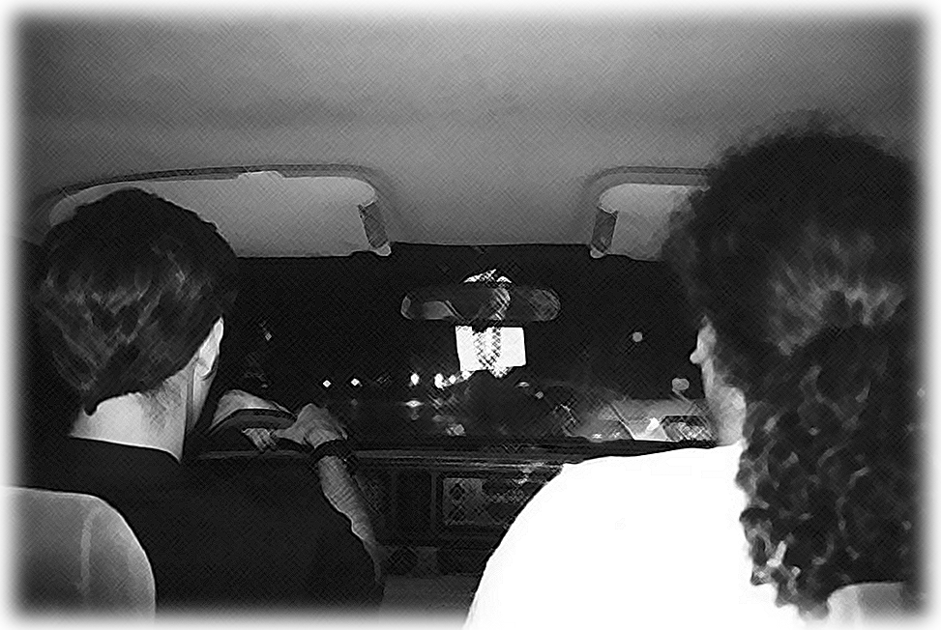
In moderation, alcohol causes people to relax and produces a sense of euphoria. But the more a person drinks, the more his or her brain is affected by the depressant quality of alcohol. This does not mean that the person feels depressed, but that parts of the brain that control behavior are depressed or “put to sleep.” Speech slurs, vision blurs, and judgment and coordination are impaired.
With enough alcohol in the body, the person’s conscious brain becomes entirely depressed, causing the person to lose consciousness. Extremely high levels of alcohol in the body can cause death when the part of the brain that controls breathing and heartbeat is depressed. In most cases, however, before a drinker reaches these extreme states of drunkenness, the body causes him or her to vomit, getting rid of alcohol in the stomach before more is absorbed into the bloodstream. This is one way the body defends itself against alcohol, which is a poison.
Since the liver filters poisons out of the bloodstream, it is the first organ damaged by long-term alcohol abuse. This leads to high blood pressure, a weakened immune system, and excess fat in the blood vessels and fat storage (like the stomach, hips, and legs). Other health problems caused by excessive alcohol abuse include ulcers, kidney and bladder damage, brain damage affecting vision and memory, and an increased risk of cancer.
In addition to the health risks of long-term alcohol abuse are injuries and deaths from alcohol-related accidents and violence. Since alcohol affects judgment, people who have had too much to drink may try dangerous stunts, including driving “under the influence.” Driving drunk is illegal. Alcohol affects vision and coordination and slows reaction time, making a drunk driver a very dangerous individual. Every year, thousands of young people die and tens of thousands are disfigured and crippled in alcohol-related car accidents.

Here are some disturbing statistics from the National Clearinghouse for Alcohol and Drug Information:
- Alcohol and other drugs are a factor in 45.1% of all fatal automobile crashes and one-fifth of all crashes involving injury.
- In 1992, drunk driving crashes claimed the lives of more than 17,000 Americans and injured 1.2 million others. Of those killed, close to one-third were under 25 years of age.
- More than 40% of all deaths of 15- to 20-year-olds result from motor vehicle crashes. In 1993, 40% of the 5,905 traffic fatalities of 15- to 20-year-olds were alcohol-related.
With their judgment affected by too much alcohol, people may also become aggressive. Alcohol is a factor in over 50 percent of murders and child abuse cases, and over 25 percent of rapes and suicides.
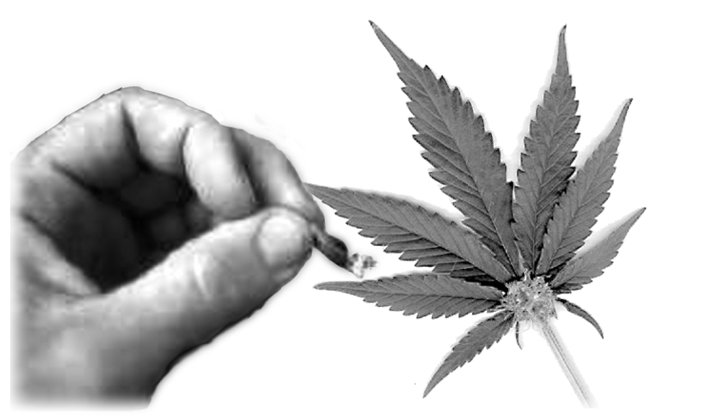
Marijuana (Pot, Grass, Weed, Dope, Reefer)
Marijuana comes from the plant cannabis, also called hemp, which is harvested and dried, and then smoked in cigarettes (joints) or pipes. The active chemicals in marijuana affect the brain, altering hearing, taste, touch, smell, and sense of time and space. The effects of marijuana vary from person to person depending on each person’s expectations and how much they smoke. In addition, the chemicals in different marijuana plants vary. People may experience anything from a mild euphoria, to uncontrollable laughter, to hallucinations.
Harmful health effects of marijuana use may include: rapid and irregular heartbeat, short-term memory loss, shortened attention span, a weakened immune system, fatigue, and a higher risk of lung cancer. In extreme cases, marijuana abuse can result in paranoia and psychosis. Like alcohol, marijuana abuse can affect driving ability. As with any illegal drug, marijuana is not tested for safety and purity. It may contain pesticides and molds and may be mixed with other dangerous drugs.

Cocaine (Coke, Crack, Flake, Rock, Snow)
Cocaine is an illegal drug that comes from the leaves of the coca bush. It is a white powder that one snorts into the nose or mixes with water and injects. It is a stimulant that affects the nervous system, providing short bursts of euphoria, a feeling of excitement, increased blood pressure and pulse rate, and alertness. People often use it to increase mental activity and to offset drowsiness and fatigue. However, the intense high of cocaine is followed by an intense low. Repeated abuse of cocaine can result in a strong physical and psychological dependency. The body will ignore all other drives, including hunger, in its drive for cocaine.
Crack is cocaine in a smokeable form. With crack, the user feels the high immediately, but the euphoria fades quickly. It is an extremely addictive drug.
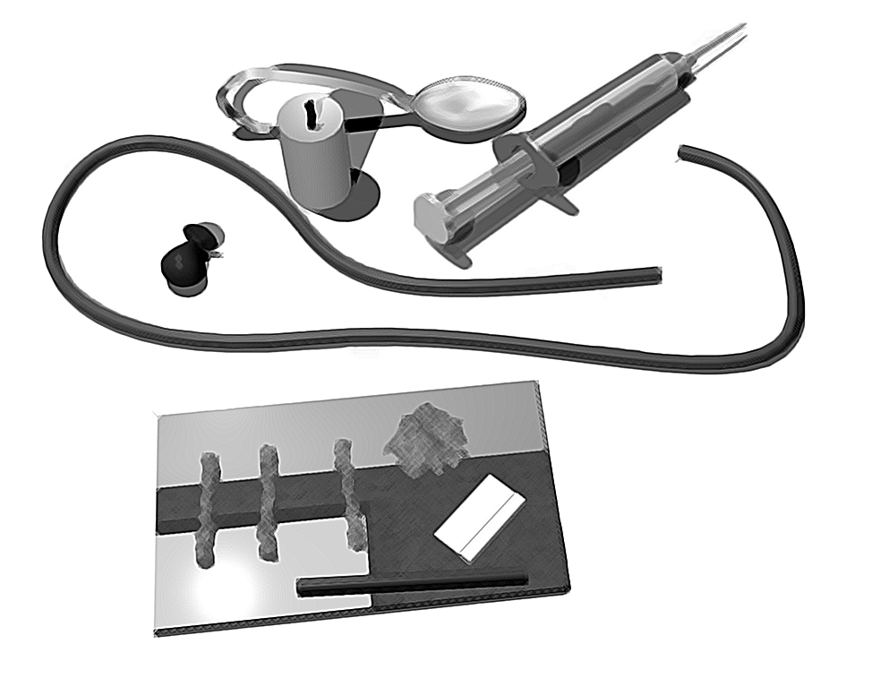
Cocaine abuse causes headaches, chronic fatigue, and destruction of nasal tissue. Pregnant women who abuse cocaine can have infants with birth defects. Cocaine addicts often lose their ability to work and have relationships. Signs of an overdose of cocaine include hallucinations, convulsions, nervousness, and high body temperature. An overdose of cocaine may result in kidney failure and death.

Amphetamines (Speed)
Like cocaine, amphetamines are stimulants. They stimulate the nervous system, increasing physical activity, energy, mental alertness, self-confidence, and producing euphoria. Medically, amphetamines are used to treat obesity, narcolepsy, and hyperactivity in children. For example, the amphetamine Ritalin is used to stimulate the brain center that helps hyperactive children sit still and pay attention.
As a drug of abuse, amphetamines are often referred to as “speed.” Many people abuse amphetamines to increase energy and alertness, and in some cases to combat fatigue brought on by use of alcohol, marijuana, or depressants. Because the body builds up tolerance to amphetamines, greater and greater doses are required to achieve the same effects. Addiction may become severe.
Medically, amphetamines are taken orally, but many abusers inject the drug directly into a vein increasing the risk of overdose and infection. Needles shared to inject the drug can spread hepatitis and Human Immunodeficiency Virus (HIV). After an injection of amphetamines, the user experiences intense, short-lived euphoria. An addict may inject the drug several times a day for several days feeling little need for food or sleep. Mental depression and overwhelming fatigue follow abuse, which may cause the abuser to turn to amphetamines again for relief.
In addition to fatigue and depression, other side effects of amphetamine abuse include extreme anxiety, temporary mental illness, and malnutrition. High doses can cause hallucinations, increased body temperature, high blood pressure, convulsions, kidney failure, lack of oxygen, bleeding of the brain, and death. Withdrawal symptoms include irritability, depression, disorientation, long periods of sleep, and not caring about anything.

Methamphetamine (Crank, Meth, Ice)
Methamphetamine is a nervous system stimulant like amphetamines that is used medically in much the same way as amphetamines. This drug is abused to produce heightened awareness, alertness, and self-confidence. A smokable form of methamphetamine is called “ice.” Like crack, it produces an intense high without the use of needles and is extremely addictive. Abuse of methamphetamine may result in bizarre behavior, sleeplessness, depression, high blood pressure, increased body temperature, convulsions, heart problems, seizures, and strokes.
Methcathinone, also called “cat” and “star,” is a designer drug similar to methamphetamine that can cause paranoia, slurred speech, tremors, extreme weight loss, and sleeplessness.

Barbiturates
Barbiturates are a group of depressant drugs that include phenobarbital (goofballs), pentobarbital (yellow jackets), amobarbital (blue devils), and secobarbital (red devils). They lower body temperature and blood pressure, slow breathing and heart rate, and as such, have many medical uses. For example, doctors prescribe phenobarbital to reduce the frequency of convulsions in epileptics. Unfortunately, people frequently abuse barbiturates, sometimes causing physical and psychological dependency.

Signs of barbiturate abuse include fatigue, blurred vision, confused or slurred speech, lack of coordination and balance, a reduction of mental and physical activity, and decreased breathing. Abusers will often act like they are drunk, but there will be no smell of alcohol. Long-term abuse may result in double vision, depression, and forgetfulness.
Signs of an overdose of barbiturates include dilated pupils, a rapid pulse, shallow breathing, and clammy skin. An overdose can cause coma and death. Barbiturates cause confusion and forgetfulness. Accidental death occurs when a person has taken barbiturates, becomes confused, forgets, and takes more barbiturates. Accidental poisoning occurs when barbiturates are combined with alcohol. Withdrawal symptoms include anxiety, insomnia, tremors, delirium, and convulsions.

Heroin (Antifreeze, Smack, Horse, Harry, Junk)
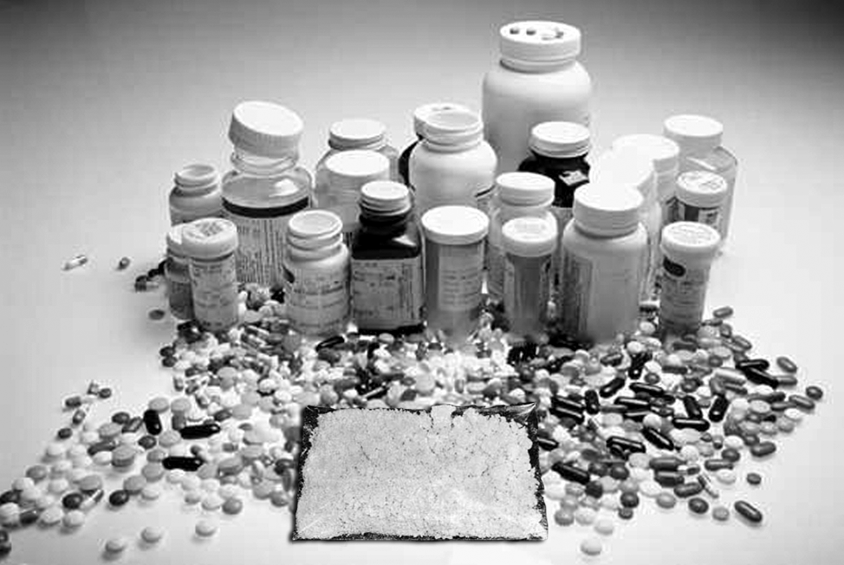
Heroin is a narcotic. Doctors prescribe narcotics to relieve pain and coughs and to cause sleepiness. Heroin, however, is so addictive that it is not used as a medicine and is illegal. Once injected, sniffed, or smoked, it dulls the senses and produces a feeling of euphoria. Other effects include drowsiness and nausea.
Signs of an overdose include shallow and slow breathing, clammy skin, and convulsions. An overdose can result in a coma and death. Once addicted, a person must have more of the drug to keep from experiencing withdrawal symptoms. Symptoms are severe and can include panic, shaking, chills, sweating, cramps, and nausea.

LSD (Acid)
LSD is a very powerful hallucinogen that scrambles and confuses the senses. A tiny drop taken with sugar or food can cause a person to “trip” or experience false visions, smells, and sounds for hours. Some people say these experiences are exciting; others say they are nightmares. Those having a “bad trip” may take dangerous or irrational actions to escape from this imaginary situation. In addition to these effects, LSD can cause nausea, vomiting, and misinterpretations of time and distance. Some people experience flashbacks of LSD’s effects days, weeks, and years after the original trip. An overdose of LSD can result in psychosis, accidental death, and suicide.

PCP (Angel Dust)
PCP, used as a tranquilizer for animals, can cause frightening hallucinations when used by humans. Abuse can result in seizures, coma, and death or in violent, unpredictable behavior. Some abusers have committed murder and suicide.

Psilocybin (Mushrooms, Shrooms) and
Mescaline (Mesc, Buttons, Cactus)
Two other hallucinogens are psilocybin, produced from a type of mushroom, and mescaline, produced from a type of cactus. Like other hallucinogens, use of these drugs can cause hallucinations, perception problems, nausea, vomiting, and, in extreme cases, mental illness, suicide, or accidental death. Mescaline effects, while compared to a mild LSD trip, are often accompanied by sweating and severe abdominal cramps. Eating mushrooms poses another danger since many mushrooms look alike and some are poisonous enough to cause death.

Inhalants (Air Blast)
Inhalants are toxic chemicals such as glue, freon, nail polish, spray paint, and gasoline that are huffed (sprayed into a cloth and held over the mouth and nose) or bagged (sniffed from a bag, bottle, or can) to achieve a brief, mild euphoria. All of these products contain labels warning against inhaling their fumes because of the hazards involved. Some inhalants used medically are also abused like amyl nitrate, which relieves heart pain and nitrous oxide, which relieves anxiety.
Risks involved with inhaling these chemicals include nausea; dizziness; vomiting; headaches; unconsciousness; pneumonia; permanent brain and nerve damage; bleeding of the brain; eventual liver, brain, and kidney cancer; and death due to heart failure and suffocation. Effects of inhalants are very unpredictable and depend on what chemical or chemicals are inhaled and how much. Brain damage and death may result after only one use depending on the inhalants involved.

Ecstasy (XTC, Love Drug)
Ecstasy is the street name for methylene-dioxymethamphetamine (MDMA), a chemical substance that combines methamphetamines with hallucinogenic properties. It is a designer drug that closely resembles cocaine. Ecstasy produces euphoria that lasts several hours, heightens pleasure, and may even produce hallucinations in high doses. Ecstasy is taken orally and may cause mood swings, overly friendly behavior, insomnia, anxiety, and nausea. In extreme cases, abuse may result in seizure and death. It is also known as X-TC, Adam, Clarity, and Lover’s Speed.
Ecstasy’s effects can last up to 24 hours. The drug produces immediate side effects, and some—such as confusion, depression, sleep problems, anxiety, and paranoia—can occur weeks after it is taken.
Ecstasy is considered a “club drug,” which is the term used to describe drugs that are commonly used at nightclubs and rave parties to enhance a person’s senses. MDMA, a stimulant and hallucinogen, is the most popular club drug, with side effects similar to methamphetamine.
Like all club drugs, ecstasy is a combination of other illicit drugs. Users cannot be completely sure what ingredients are in the drug they are taking. The drug quality of ecstasy may vary significantly from one dose to another, so that one dose may be more potent than another and the drug may be combined with other drugs without the user’s knowledge. Because many different recipes are used to make ecstasy, the risk of death and permanent brain damage are heightened when some substances are combined. It is available in tablet, capsule, or powder form; some manufacturers of the drug package it in capsules or generic tablets to imitate prescription drugs. The average cost is between $7 and $30 per pill.
Among the variations of the drug is a new substance, herbal ecstasy, which is composed of ephedrine (ma huang) or pseudoephedrine and caffeine from the kola nut. Sold in tablet form, this drug may cause permanent brain damage and death (NIDA, Club Drugs: Just the Facts, 2000).
The drug, which induces intense euphoria and lowers inhibitions, is particularly trendy among middle class teenagers and young adults and has exploded in popularity in recent years. The DEA estimates 2 million ecstasy tablets are smuggled into the United States every week.
The drug is appealing to youth who attend raves because it increases the visual appeal of rave light shows and gives them energy so that they can dance for hours at a time. However, youths may not be aware of the many risks associated with using ecstasy. The drug produces many side effects, including nausea, hallucinations, chills and sweating, increases in body temperature, involuntary teeth clenching and muscle cramping, tremors, blurred vision, confusion, anxiety, paranoia, and depression.
Other serious side effects commonly exist. Ecstasy users tend to experience a decrease in sexual and emotional inhibitions. This increases the likelihood of youths under its influence having unprotected sex and sex with multiple partners. Users have nicknamed it the “hug drug” since it encourages physical interactions. However, because their judgment is impaired, these youth are susceptible to being infected with sexually transmitted diseases.
The problem for parents and others who worry about ecstasy use is that the drug shows none of the obvious physical signs of other illegal drugs. It is not considered physically addictive, and there is no odor or slurred speech to detect.
Raves
The dance parties known as “raves” are widely considered notorious havens for illegal drugs like ecstasy. By definition, raves are parties where pulsating music, special effects such as steam, and paraphernalia such as pacifiers, chemical light sticks, and flashing light rings are used to support highs from club drugs.
Raves themselves are nothing new. They have been popular since the late 1980s, originating within the gay club culture of after-hours' parties. The music, notable for its highly regimented and precise dance beats, began first in Detroit with club DJs sampling early disco records and blending them with new, faster beats. The music then moved to England, where the sound changed again and was exported back to the U.S., where it continues to evolve.

Rohypnol (Roofies, Forget Pill, Date-Rape Pill)
Rohypnol is used legally as a medical sedative in Europe and Latin America. As a drug of abuse, it is called roofies, forget pill, and date-rape pill. At first, it produces an alcoholic type of high, then heavy sedation and short-term memory loss that lasts up to eight hours. It earned its reputation as the date-rape pill by being slipped into the drinks of females, who were taken advantage of in a state of sedation brought on by the drug and then unable to remember exactly what happened to them. In addition to the drawback just discussed, dangers of abusing rohypnol include impaired motor skills and slow respiration.

Signs of Drug Abuse
- Dilated pupils
- Missed appointments
- Lying
- Unexplained increases in energy followed by fatigue and depression
- Anxiety
- Memory loss
- Pale and perspiring skin
- Runny nose
- Nosebleeds
- Hyperactivity
- Jumpiness
- Ability to go without food or sleep for long periods of time
- Suspiciousness and paranoia
- Lack of care with personal appearance
- Inability to explain what money is spent on
All of these signs of drug abuse may also be caused by other medical, psychological, or personal problems. If a friend or family member is showing one of the signs, it is in no way an absolute indication that he or she is abusing drugs. Before jumping to conclusions, consider how frequently these signs occur and if the person showing the signs has a logical explanation for them. Expressing concern and asking questions is the best way to get a person to confide in you.
If a friend or family member is abusing drugs, make it clear that you care about him or her, but that you do not approve of his or her habit. Encourage the person to break the habit and support any effort on the part of the person to do so. Find out where the person can seek help and encourage him or her to get it.
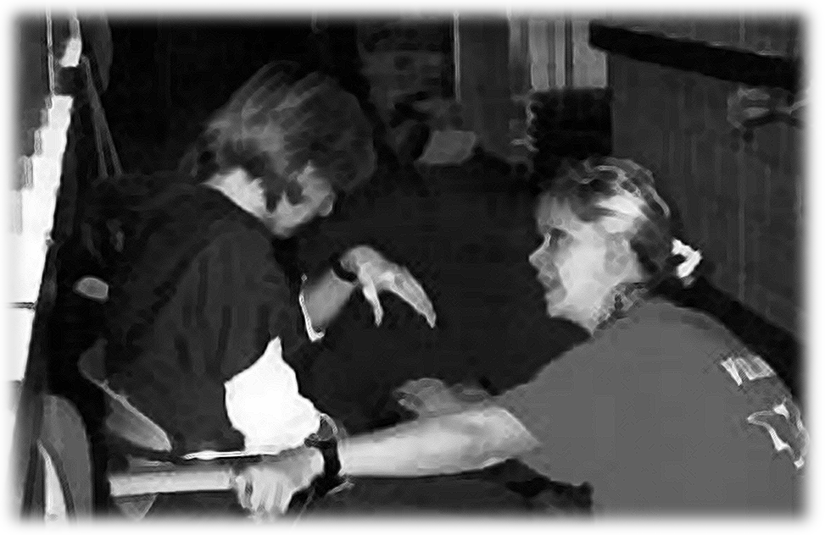
Indicators of Alcohol Abuse
Alcohol abuse has an adverse effect on logic, coordination, social behavior, and school or job performance. The symptoms or warning signs of alcohol abuse include the following:
- Hangover – the nausea, headache and dry mouth following heavy drinking.
- Blackout – The temporary loss of consciousness, vision, or memory as the result of substance abuse.
- Fatigue – the depressed after-effect of alcohol abuse; the state of mind after too much partying and too little rest.
- Illness – The more frequent the abuse, the more likely the need for some type of medical assistance. Frequent calling in sick for work or school, tardiness, and/or below standard performance. Wild weekends have a tendency to borrow from Fridays and overlap Mondays.
- Conflict – The frequent substance abuser may become abusive in social situations. Sometimes the “life of the party” goes beyond what is considered socially acceptable behavior and becomes an embarrassment to him/herself and to others.
There are many indicators of a pre-alcoholic or an early alcoholic situation. Some things to looks for, in others as well as in yourself, that may indicate an alcohol problem are among the following:
- Cannot control drinking; gets drunk when intending to stay sober.
- Using alcohol as a tranquilizer to quiet nerves.
- Other people say you drink too much.
- Being in trouble with the law, your family, the people you work with, or with teachers, administrators or fellow students at school as a result of drinking.
- Being dependent on alcohol and not being able to stop drinking for a week or more.
- Your doctor tells you that your drinking is impairing your health.
- Drinking before you go to a party just in case there will not be drinking there.
- Having a drink in the morning to cure a hangover or the shakes.
- Development of a tolerance for alcohol.
There is evidence to indicate that a tendency toward alcoholism could be hereditary. People who have a family member with a drinking problem should be extra careful of their drinking habits.

Social Consequences of Alcohol and Drub Abuse
Alcohol and other drug use is often a factor in many of this country’s most serious and expensive problems, including violence, injury, child and spousal abuse, HIV/AIDS and other sexually transmitted diseases (STDs), teen pregnancy, school failure, car crashes, escalating health care costs, low worker productivity, and homelessness (Center for Substance Abuse Prevention’s Discussion Paper on Preventing Alcohol, Tobacco, and Other Drug Problems, 1993). Former Secretary of Health, Education and Welfare Joseph A. Califano, Jr. estimates that in 1993, the cost to society of alcohol, tobacco, and other drugs was nearly $400 billion – about $1,608 for every man, woman and child in the nation (Center for Addiction and Substance Abuse, Columbia University, The Cost of Substance Abuse to America’s Health Care System, Report 1: Medicaid Hospital Costs, 1993).
Crime
Crime is closely related to alcohol and other drugs. The U.S. Department of Justice, Bureau of Justice Statistics publishes reports in both 1991 and 1992 entitled Crime in the United States. It its reports, the Justice Department claimed that there were more than 1.1 million arrests for illicit drug violations, almost 1.4 million arrests for driving while intoxicated, 480,000 for liquor law violations, and 704,000 arrests for drunkenness. The total of all these arrests comes to 4.3 million arrests for alcohol and other drug statutory crimes, over one-third of all arrests in this country.
The need for preventing alcohol and other drug problems is clear when you examine the following statistics:
- Alcohol is a key factor in up to 68% of manslaughters, 62% of assaults, 54% of murders/attempted murders, 48% of robberies, and 44% of burglaries.
- Among jail inmates, 42.2% of convicted rapists reported being under the influence of alcohol or alcohol and other drugs at the time of their offense.
- In 1990, over 60% of men and 50% of women arrested for property crimes (burglary, larceny, robbery), tested positive for illicit drug use. It should be pointed out that these individuals were voluntarily tested.
- The number of potential years of life lost to alcohol- and drug-related injuries equals the number of potential years lost to cancer. The potential years of life lost to alcohol- and drug-related injuries exceeds those years lost to heart disease. Cancer and heart disease are the two leading causes of death in the U.S.

Domestic Violence
Studies of domestic violence frequently reveal high rates of alcohol and other drug involvement. This is not unexpected since both alcohol and other drug use is known to impair judgment, reduce inhibition, and increase aggression. Similar to the link between domestic violence and substance abuse, alcoholism and child abuse, including incest, seem tightly related as well. Abusers tend to be heavy drinkers and those who have been abused have a higher probability of abusing alcohol and other drugs over the course of their lifetime. Studies reveal a strong association between battering incidents and alcohol abuse. The combined problem of the abuse of alcohol and other drugs is even more likely to be connected with the more severe battering incidents than is alcohol alone.
The Link to Risky Sexual Behavior
Alcohol and other drug use is linked to risky sexual behavior. This link represents a significant threat to the teens’ health. Substance abuse may impair a teen’s ability to make judgments about sex and contraception. This places young men and women at an increased risk of unplanned pregnancy, sexual assault, or becoming infected with a sexually transmitted disease.
Suicide
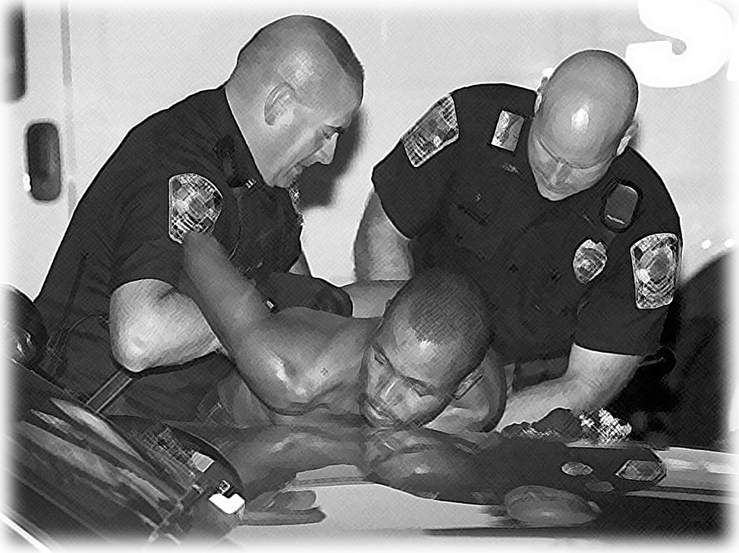
Researchers “cite a wide range of potential suicide triggers, from loss of employment or loved ones, aging and physical impairment. But, in most cases, they agree there is an underlying psychiatric illness – primarily depression, followed by alcoholism and substance abuse” (“The Mystery of Suicide,” Newsweek, April 18, 1994). In one study of youth suicide, drug and alcohol abuse was the most common characteristic of those who attempted to kill themselves. Fully 70% of these young people frequently used alcohol and/or other drugs. (U.S. Department of Education, “Youth & Alcohol: Selected Reports to the Surgeon General,” 1993).
Economic Costs of Alcohol- and Drug-Related Abuse
Incidents of drug and alcohol abuse exact a huge economic cost in this country. Alcohol-related injuries alone cost an estimated $47 billion annually. A 1993 study reported that illnesses and injuries caused by the use of alcohol, tobacco, and other drugs accounted for nearly 40% of the medical costs at one large metropolitan hospital (Center for Substance Abuse Prevention’s Discussion Paper on Preventing Alcohol, Tobacco, and Other Drug Problems, September, 1993).
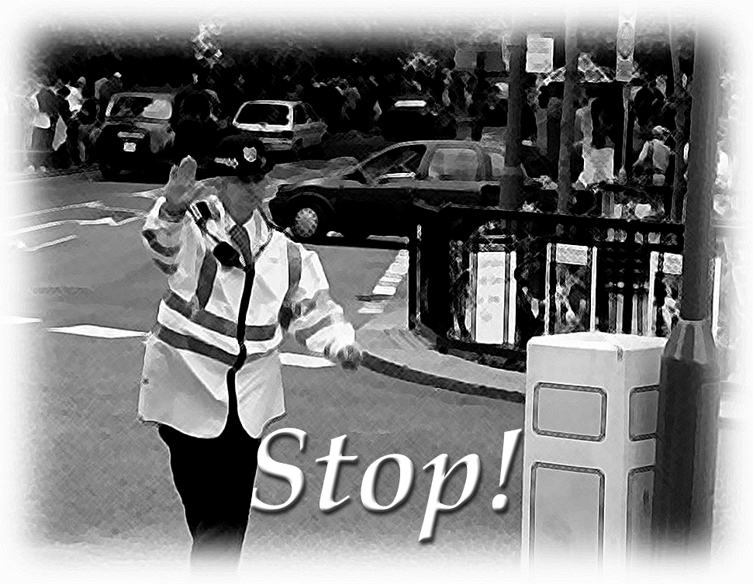
U.S. companies spend over $100 billion each year addressing workplace alcohol- tobacco- and other drug-related problems (Working Partners: Confronting Substance Abuse in Small Business, National Conference Proceedings Report, U.S. Department of Labor, 1992). Studies show alcohol and other drug abusers:
- Are less productive;
- Use three times as many sick days;
- Are more likely to injure themselves or others; and
- Are five times more likely to file worker’s compensation claims.
For more information about alcohol and drug related problems, call the National Clearinghouse for Alcohol and Drug Information at 1-800-729-6686.

What Can You Do to Remain Drug-Free?
- Fill your life with activities and people you enjoy.
- Believe in yourself.
- Practice saying no before you are actually in a situation where someone offers you drugs, so you will not hesitate to say no when the time comes.
- Think through the consequences of abusing drugs. Where will drugs lead you in life? How long will your body remain healthy if you abuse drugs? How many of your plans can drugs ruin?
- Remember that drugs do not solve problems; they create them.

Conclusion
When drugs are properly used, they can cure illness and save lives. When abused, however, drugs can destroy lives and cause death. It is important to understand that, while people often abuse drugs to find happiness and fulfillment, drugs only create more problems and unhappiness. To keep from falling into the trap of drug abuse, stay smart, strong, and active. Say “no.” Recognize the different drugs that are abused in our society and what affect they have on people’s health and lives. You can set an example of an informed, drug-free individual. 

