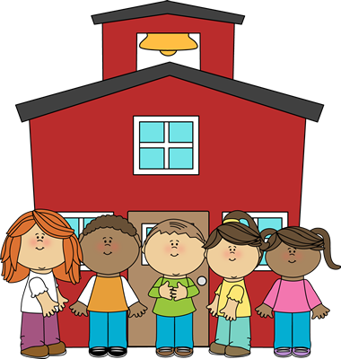

The Kindergarten Connection
September 2025

Savvas Unit 1 – Going Places

What Makes a Place Special?

Week 1: Mission Accomplished- How Does imagination make a place seem different?

Week 2: Too Many Places to Hide- What is exciting about moving to a new place?

Week 3: At the Library- What makes us want to visit a special place?

Week 4: Where is Twister?- What is fun about exploring a new place?

Week 5: A Visit to the Art Store- How can we describe a special place?
Language Arts

Listening and Following Directions
Rhyming
Writing first names
Writing Explorations: Drawing/Dictating
UFLI sounds: short a, m, s, t, p, f, short I, n, short o, d, ck, short u (VC & CVC words)
Math
2-D Shapes
3-D Shapes
Count, Write, and Represent Numbers Through 5

Social Studies
“I-Care Cat” – Citizenship
Patriot Day & Constitution Day
Hispanic Heritage Month

Science
5 Senses
I am a Scientist / Science Tools

Florida State Standards

Link to the BEST Standards (ELA): https://www.fldoe.org/core/fileparse.php/7539/urlt/elabeststandardsfinal.pdf

Link to the BEST Standards (Math)): https://cpalmsmediaprod.blob.core.windows.net/uploads/docs/standards/best/ma/mathbeststandardsfinal.pdf

Important Dates

September 1st Labor Day- No School

September 5th First Friendship Friday

September 9th Skate World Fundraiser

September 11th Patriot Day

September 12th “Me” Family Project Due

September 17th Constitution Day

September 23 K Activity Fee Due (efunds)

Reminders
- Please send a change of clothing for your child to keep at school.
- Please be sure to label all lunchboxes, snack bags, jackets, and change of clothes with your child’s name.

The Kindergarten Teachers,

Mrs. Campbell, Mrs. Deason, Mrs. Lindsey, Mrs. Ramos, Ms. Randall, Mrs. Rockwood, Ms. Hammond, & Ms. Lindquist

