The Kindergarten Connection
September 2023
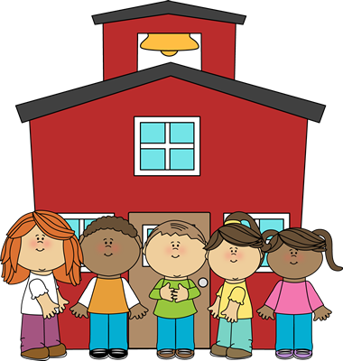
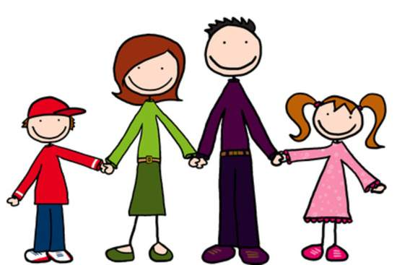

Savvas Unit 1 – Going Places

What Makes a Place Special?

Week 1: Mission Accomplished- How Does imagination make a place seem different?

Week 2: Too Many Places to Hide- What is exciting about moving to a new place?

Week 3: At the Library- What makes us want to visit a special place?

Week 4: Where is Twister?- What is fun about exploring a new place?

Week 5: A Visit to the Art Store- How can we describe a special place?
Language Arts
Listening and Following Directions
Rhyming
Writing first names
Writing Explorations: Drawing/Dictating
UFLI sounds: short a, m, s, t, p, f, short I, n, short o, d, ck, short u (VC & CVC words)
Math
Count, Write, and Represent 1 through 4
Count, Write, and Represent Numbers Through 5
Compare Numbers Through 5

Social Studies
“I-Care Cat” – Citizenship
Science
5 Senses
I am a Scientist / Science Tools

Florida State Standards

Link to the BEST Standards (ELA): https://www.fldoe.org/core/fileparse.php/7539/urlt/elabeststandardsfinal.pdf

Link to the BEST Standards (Math)): https://cpalmsmediaprod.blob.core.windows.net/uploads/docs/standards/best/ma/mathbeststandardsfinal.pdf

Important Dates

September 4th Labor Day- No School

September 17th Constitution Day

September 21st Open House, 6:05-6:35pm (RESCHEDULED)

September 25th Fall Holiday – No School

Reminders
- Please send a change of clothing for your child to keep at school.
- Please be sure to label all lunchboxes, snack bags, jackets, and change of clothes with your child’s name.

The Kindergarten Teachers,

Mrs. Campbell (& Miss Rwito), Mrs. Deason, Mrs. Lindsey,

Mrs. Manuel, Mrs. Ramos, Ms. Randall, Ms. Hammond, & Ms. Linquist

