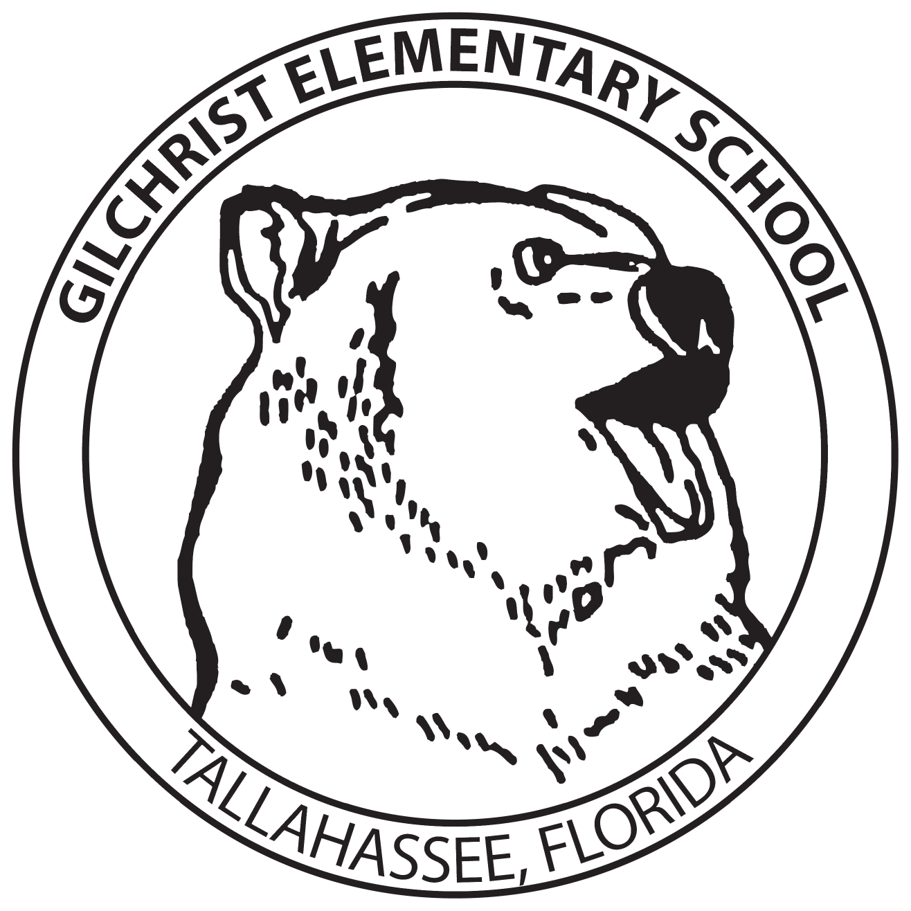

PARTNERS FOR EXCELLENCE
SPONSORSHIP SIGNS

32” X 48” Field Sign – Cost $350
Signs will face the front driveway at Gilchrist (Edna Owens Lane)
Sponsor signs are valid for 12 months
Renewals will be available at the cost of $250 and will be requested 30 days prior to expiration.

Artwork should be electronically sent directly to kirschhn@leonschools.net

Sponsor Name: _______________________________________________

Address: _____________________________________________________

City, State, Zip: _______________________________________________

Contact Person: _______________________________________________

Phone: ____________________ Email: ____________________________

Date: _____________________ Signature: ________________________

Please make checks payable to:
Gilchrist Elementary School
Return payment and this form to:
Business Partner Coordinator Hannah Kirsch
1301 Timberlane Road
Tallahassee, Florida 32312
Phone: (850) 487-4310 Fax: (850) 487-0959

