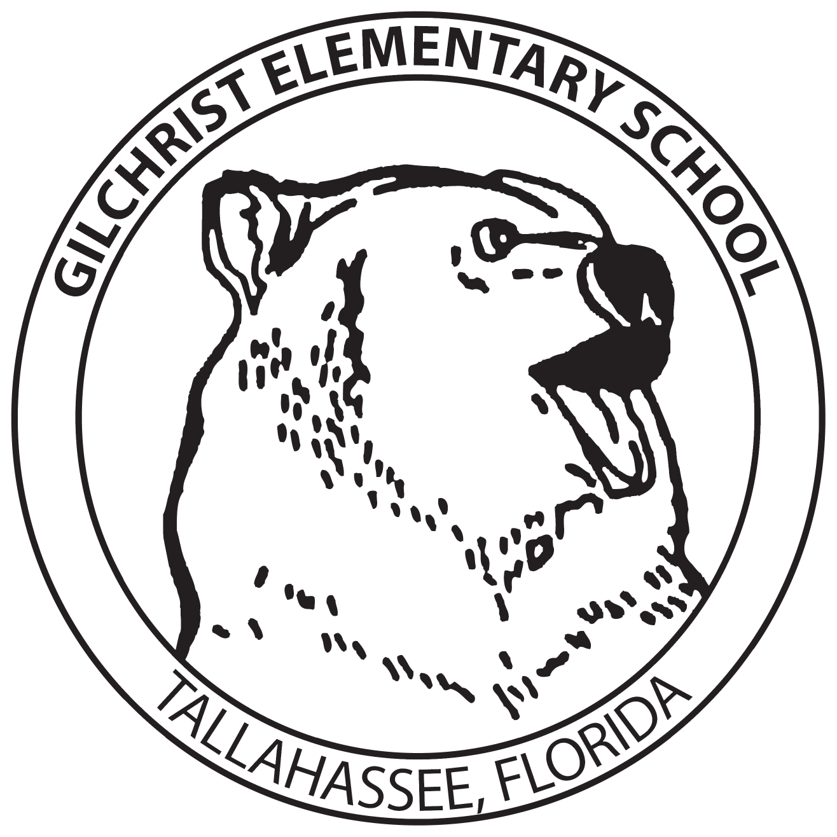

Business Partner Packet

Gilchrist Elementary School

2019 – 2020 School Year

“Education is for improving the lives of others
and for leaving your community and world better than you found it.”
Marian Wright Edelman

Gilchrist Elementary School
Gee it’s a great place to be!

Gilchrist Mission Statement
"The Gilchrist Family of Life-Long Learners" - students, teachers, staff, parents, and community members - is committed to an on-going planning process that will ensure a quality learning environment, state-of-the-art facility, and a curriculum that will be the foundation for this life-long learning.
Gilchrist commitment to our Community
Gilchrist Elementary School has been a fixture in the Tallahassee community for 50 years. It’s commitment to producing life-long learners has been an invaluable asset to Tallahassee, local businesses, civic organizations, and beyond. Since the doors opened in 1966, as then Timberlane School, Gilchrist has been known to have a tradition of high academic and leadership standards. Throughout the years, Gilchrist has received many awards and accolades such as being named an A school for 15 years in a row and receiving a Blue Ribbon School Award from the U.S. Department of Education. However, its greatest accomplishment is its students. They have gone on to be student body presidents, college athletes, singers, artists, public servants, doctors, lawyers, teachers, elected officials, and many other professions that benefit our community and world.

We hope that you and your business can commit yourselves to ensuring that Gilchrist Elementary School remains a tradition in excellence.

We look forward to working with you during the 2019-2020 school year!

Hannah Kirsch
Business Partner Coordinator
Gilchrist Elementary School
1301 Timberlane Road
Tallahassee, Florida 32312

www.leonschools.net/gilchrist
kirschhn@leonschools.net
850.487.4310

Partners for Excellence Opportunities
Gilchrist Elementary School
2017-2018 School Year

Our school’s excellence is a community effort! We hope you can find a place to get involved and make an impact on our students, teachers, staff, and families. Please review the opportunities below and check all the areas that are of interest to your business.

Ongoing School Activities:
__ Report card incentives (1050 coupons needed per grading period)
__ Faculty/Staff recognition (funding, coupons, provide meals, gift cards, etc.)
__ Gilchrist Family Share Nights (sponsor a Family Share Night at your place of business and donate a portion of the revenues back to Gilchrist)
__ Landscaping materials (donate plants, trees, mulch, topsoil, or pine straw)
__ Provide a discounted meal menu and lunch delivery for staff members
__ Mentoring (employees serve as mentors to a student once a week)
__ Any service that your company provides that we might not have mentioned, but would be helpful to our school: __________________________________________________________________________________________________________________________

Short Term Activities:
__ Outstanding personnel recognition (provide gift certificates)
__ School/community events (provide volunteers)
__ Serve as judges (Tropicana Speech Contest, Spelling Bees, etc.)
__ Classroom presenters (I can talk to children about the following: ______)
__ Sponsor 4th grade restaurant week in May (50 students per restaurant)
__ Sponsor Science week hands on activities in January
__ Adopt school families in need (provide food/clothing)

Business Name: ____________________________________________________________
Work # ________________________________ Cell# _______________________________
E-mail: _____________________________________________________________________
Contact Person: ____________________________________________________________

Our school greatly appreciates any and all services that your business can provide to Gilchrist’s students, teachers, staff, and the 1000 plus families that we interact with on a daily basis. Without our community, our school would not be one of the top schools in Tallahassee. We thank you in advance for your generous spirit!

