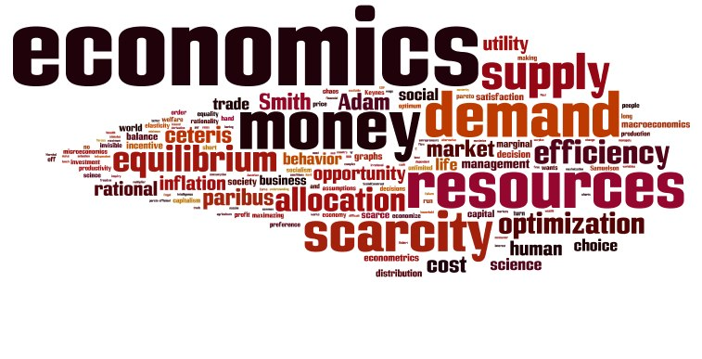
Economics Honors with Financial Literacy
Mrs. Jennifer Powell, M. Ed.
Lawton Chiles High School – Room 7205
powellj@leonschools.net
850-488-1756

Course Description: The purpose of this course is to give students a thorough understanding of the principles of economics, how those principles are applied within the U.S. system, and to create and teach a strong personal finance foundation. The course places particular emphasis on the study of macro and micro economic fundamentals, economic systems, supply and demand, business organization, savings and investment, public policy and economic interdependence. Completing this course with a passing grade will fulfill the graduation requirement for economics. Please remember: A passing grade is required in this course for graduation.

Course Outline:
Unit 1: Fundamentals of Econ Unit 2: Economic Systems Unit 3: Supply and Demand
Unit 4: Business Organizations Unit 5: Macroeconomics Unit 6: Public Policy
Unit 7: Globalization and Trade Unit 8: Financial Literacy

Sunshine State Standards: Available online at www.floridastandards.org/Standards/FLStandardSearch.aspx

Financial Literacy: The state has mandated an extensive area of study in Personal Finance. This will take specific and focused looks and study in multiple components of personal finance. These components include: Dangers of Debt, Types of Credit, Budgeting, Saving, Investing, and Career and Goal Planning.

Course Texts and Readings:

Economics, Principles in Action; Pearson/Prentice Hall. – Textbook

Additional Reading: Beyond the textbook, we may read newspaper and magazine articles, and excerpts from books and online texts.

Materials: 3 ring binder or folder, loose-leaf notebook paper; college or wide rule, blue or black pens or pencil.

Grading Scale: A=100-90 B=89-80 C=79-70 D=69-60 F=59-0
- Tests will be given at the conclusion of each units, which generally covers three chapters from the course text.
- Quizzes are generally conducted throughout each chapter studied and will cover vocabulary, notes or assigned readings. Pop quizzes can be given at any time.
- Homework will consist of question sets, copying vocabulary, reading passages, or worksheets. Worksheets will be posted online. Students are responsible for obtaining the worksheets from the course website.

Late Work: Homework will be turned in at the beginning of class. No late homework assignments will be accepted.

Class Expectations/Procedures
1. Students will come to class with all necessary supplies (see above.).
2. Students will not bring food, drink or gum into the classroom. Any student bringing food, drink or gum into the classroom will be asked to throw it away. Repeated violation of this rule will result in detention.
3. Students will not use cell phones, iPods, or other electronic devices in the classroom.
4. Students will be polite and respectful toward teacher and classmates. Students will raise their hands and wait to be recognized before speaking and will be respectful of opinions/views that differ from their own during class discussions and debates.
5. Students are expected to maintain their academic integrity and to work independently unless instructed differently by the teacher. If caught copying work, all students involved will receive zeros on the assignment. The Chiles Honor Code will be enforced.
6. This is an honors course and, as such, requires more effort, maturity, and focus. Work should be completed to the best of your ability and ON TIME. Late work will not be accepted.
7. Students will return all books and materials to their proper place before leaving class. Students are expected to leave their desk areas neat and free of trash.
8. Students are allowed 3 passes out of class per 9 weeks. (Can be used for restroom, retrieving forgotten materials, etc.)
9. The teacher, not the bell, dismisses class.
Tardy Policy: Students will be in their seats prepared to work when the bell rings.
1st Tardy – Warning 2nd Tardy – Parent Contact 3rd Tardy – Teacher Detention 4th Tardy – Referral
Any infraction of these expectations or procedures may result in disciplinary action.

Honors Courses: Economics is a required course at Lawton Chiles High School but taking it at the Honors level is voluntary. Honors courses are intended to help prepare students for the rigors of college and are therefore more difficult and require more work. The extra effort put forth in Honors courses is shown to colleges by adding weight to the grade points earned in class towards a student’s overall grade point average (GPA). Students who volunteer to take an Honors course are volunteering to do the extra work and put forth the extra effort necessary to earn the added “weight” to their GPA.

Attendance/Make-up Policy
- Following an absence, the district policy will apply (1 day for every day absent) to determine how much time the student has to make-up the work and then submit it. It is the student’s responsibility to request make-up work after an absence.
- An absence before the day of a test or quiz that a student was informed of does not excuse them from the test or quiz. If a student misses a test, they will have one week to make up the test. After one week, there will be a percentage deduction for each additional week that the student takes to complete the test
- If a student misses a quiz, students will have one week to complete the quiz or they will receive a zero for that quiz. Once one week has passed from the day that the initial quiz was administered, students will not be able to make that quiz up.
Tips for Success in this Course:
- Take complete class notes and date them. Put them in your OWN words. Don’t write down something you don’t understand without asking about it. It is very important to review your class notes each day while they are still fresh in your mind. Expand them, clarify them, and add examples so that they will make sense when you go back to study from them later.

- Learn to read more effectively. You can read more effectively by reading actively (using sticky notes or highlighters as you read), paying attention to pictures, diagrams, tables, and sidebars in your textbook and by taking notes as you read.

- Vocabulary is your ticket to success in this class. You will be expected to keep a running log of the core vocabulary for this course and vocab quizzes will be given throughout the semester. As you define the terms, you are developing your vocabulary skills and learning the content. Don’t cheat yourself out of this learning task and opportunity.

Class Wish List: Any of the following items are super appreciated as they assist with class projects and keeping germs at bay. Thank you in advance for making our classroom environment productive and more enjoyable!
Kleenex, Glue Sticks, Highlighters, Colored Pencils, Markers, Hand sanitizer, Band-Aids, Ziploc bags, Colored or white copy paper
Please sign and return the attached document, acknowledging the course outline and your acceptance of the class rules, policies and procedures.
We have read and understand the expectations, policies and procedures specified for Mrs. Powell’s Honors Economics with Financial Literacy course.

_________________________ _________________________
Student Name (print) Student Signature
________ Period

_________________________ __________________________
Parent/Guardian Name (Print) Parent Signature

_____________________
Parent Home Number

_____________________
Parent Cell Phone Number

_____________________
Parent Email

