How to use the Online Textbook

1. Log onto the computer with your username and password
2. Open Google Chrome | 
3. Go to the Deerlake Webpage and click on ClassLink
4. Click on your textbook: myHRW | 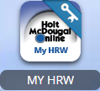
5. Drop down to “Go Math, Pre-Algebra”
6. Click on the Student Online Edition | 