
Strawberry DNA Extraction Lab by C. Kohn, WUHS and Stacy Fritz, NAAE
Name: Hour Date:
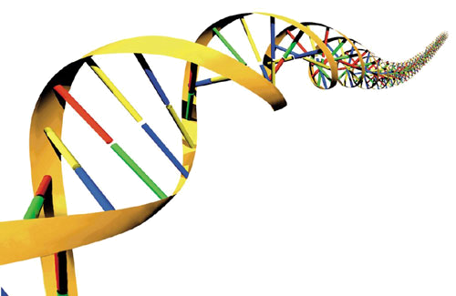
Date Assignment is due: At end of hour Why late? Score: /10
^{Day of Week} ^{Date} If your project was late, describe why
Materials
- ice-cold rubbing Extraction liquid
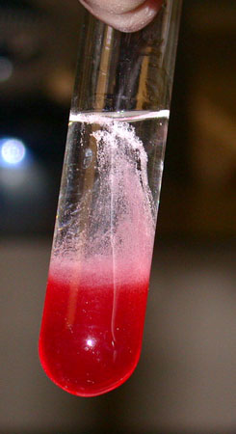
- Coffee Filter Re-closable plastic sandwich bags test tube (or small glass jar)
1 strawberry (green tops removed) cup toothpick
Directions:
- Put the strawberries in the plastic bag and push out all the extra air. Add some extraction liquid and Seal it tightly.
- With your fingers, squeeze and smash the strawberry mixture for 2 minutes.
- Put coffee filter over the cup and Pour the strawberry mixture from the bag into filter. Let it drip into the cup. BE CAREFUL
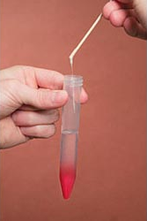
- Throw away the filter and the strawberry pulp inside. Pour out the contents into the test tube
- Pour the contents of the mixture into the test tube so it is 1/4 full.
- Tilt the test tube or jar and very slowly pour the cold rubbing alcohol down the side. The alcohol should form a layer on top of the strawberry liquid. (Don’t let the alcohol and strawberry liquid mix. The DNA collects between the two layers!). Slowly add enough alcohol so that you have equal parts of both liquids.
- Dip the toothpick into the test tube where the alcohol and strawberry layers meet. Pull up the skewer. The whitish, stringy stuff is DNA containing strawberry genes!
Questions
- List and describe one thing that you found surprising or interesting that you learned from this lab

