Name ___________________________________________________________________ Date _________

WAVES AND ELECTROMAGNETIC SPECTRUM- Study Guide Key

*Define the following Terms*

1. *Wave: Repeating movement or disturbance that transfers energy through space or matter*
2. *Crest: Crest is the highest point of a transverse wave*
3. *Transverse Wave: Waves that move parallel- have two parts a crest and a trough. Think Ocean waves*
4. *Longitudinal Wave: Wave by which energy moves in the same direction as the initial starting point. Think compressional waves*
5. *Compressional wave: Longitudinal wave with two parts, compressions (where the most energy is found) and rarefactions (least energy).*
6. *Electromagnetic spectrum: The entire range of electromagnetic wave frequencies including light, sound, x-ray, gamma rays, radio waves and ultraviolent waves*

*Short Answer*

1. What is the distance between two corresponding parts of a wave called? Wavelength
2. What is the difference between reflection and refraction? Give an example of each.

*Reflection- waves bounce back or reflect off an object (think mirror, sound waves, light waves)*

*Refraction: The waves bend based on speed. Think Pencil in the water and how it looks broken.*

1. What kind of electromagnetic wave is being used when a police officer uses radar for speed control? Radio waves
2. What kind of waves do cellular telephones use to transmit and receive signals?

*Microwaves*

1. Cell phone signals are transmitted by what type of waves?

*Radio waves*

*Fill in the Blank*

1. __radio___ waves carry information from a broadcasting station to your radio or television.
2. In a compressional wave moving along a spring, areas where the coils are farthest apart are called _rarefactions _.
3. The _amplitude_ of a mechanical wave is a direct measure of its energy.
4. The material through which a wave travels is called a (an) _**medium**__.
5. The part of the electromagnetic spectrum you can see is called **Visible**  light.
6. **X-rays**  are used to make images of bones inside the human body.
7. AM signals travel as changes in the **_amplitude**_ of a radio wave.

*Use the diagram to answer each question*.

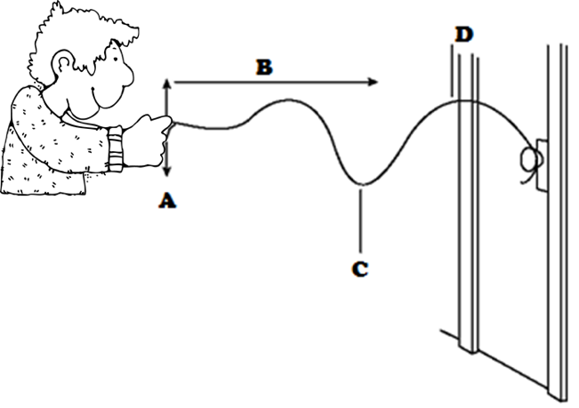

21. What does the person transfer to the rope by pulling it up and down at point A?

Energy

22. What does the direction of arrow B indicate?

The direction in which the wave is moving

23. In what direction does the medium move relative to the direction of the wave? Explain.

Parallel to the length of the rope- in the direction the energy is moving through the wave

24. What kind of wave is being generated?

Transvers Wave

35. What does point C represent?

Trough

36. What is the medium through which the wave is moving?

The Rope