Name ___________________________________________________________________ Date _________

WAVES AND ELECTROMAGNETIC SPECTRUM- Study Guide

*Define the following Terms*

1. *Wave:*
2. *Crest:*
3. *Transverse Wave*
4. *Longitudinal Wave*
5. *Compressional wave*
6. *Electromagnetic spectrum*

*Short Answer*

1. What is the distance between two corresponding parts of a wave called?
2. What is the difference between reflection and refraction? Give an example of each.
3. What kind of electromagnetic wave is being used when a police officer uses radar for speed control?
4. What kind of waves do cellular telephones use to transmit and receive signals?
5. Cell phone signals are transmitted by what type of waves?

*Fill in the Blank*

1. __________________ waves carry information from a broadcasting station to your radio or television.
2. In a compressional wave moving along a spring, areas where the coils are farthest apart are called ____________________.
3. The ____________________ of a mechanical wave is a direct measure of its energy.
4. The material through which a wave travels is called a (an) ____________________.
5. The spreading out of waves after they pass through a narrow opening is ____________________.
6. Red light has the longest ____________________ of any color of visible light.
7. The part of the electromagnetic spectrum you can see is called ____________________ light.
8. ____________________ are used to make images of bones inside the human body.
9. AM signals travel as changes in the ____________________ of a radio wave.

*Use the diagram to answer each question*.

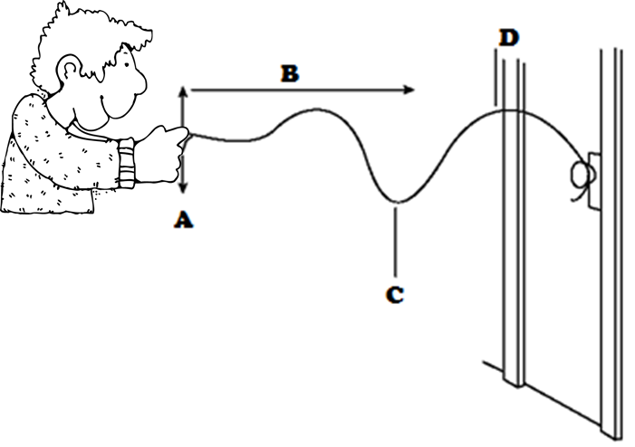

21. What does the person transfer to the rope by pulling it up and down at point A?

22. What does the direction of arrow B indicate?

23. In what direction does the medium move relative to the direction of the wave? Explain.

24. What kind of wave is being generated?

35. What does point C represent?

36. What is the medium through which the wave is moving?

*Use the diagram to answer each question*.

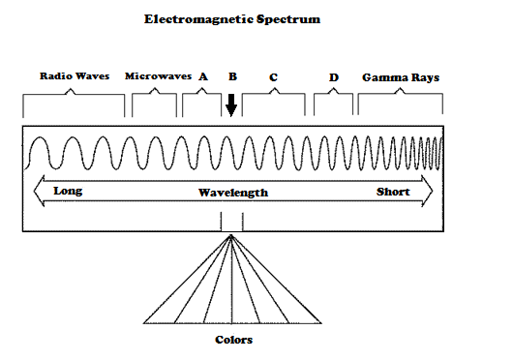

37. Name the type of wave that has the highest frequency.

38. Name the type of wave labeled C.

39. Name the type of wave that has the greatest energy.

40. Which letter shows the type of wave that can be seen by the human eye?

41. Name the type of wave labeled A.

42. Which letter indicates X-rays?