**Topic -4 Plate Tectonics-Study Guide (25 Pts – Homework Grade)**

***Test Date: Tuesday 3/5/2019 Study Guide Due: Tuesday 3/5/2019***

***_________________________________________________________________________***

1. **Study your Continental Drift Quiz- ALL OF IT!! There will be questions from this quiz on your test!!!!**
2. **Which layer consists of the Earth’s crust and upper mantle divided into tectonic plates?**
3. **What characteristic of the outer core makes it unique among the layers of the Earth?**
4. **What is the source of energy that drives Earth’s plate tectonics, earthquakes, and volcanic eruptions?**

**A.** tidal energy from Earth's oceans **B.** heat energy from Earth's molten layers

**C.** magnetic energy from Earth's magnetic field **D.** light energy from the Sun that reaches Earth

1. **How does the movement of tectonic plates create new mountains?**
   1. When one plate gets pulled underneath another, the crust piles up underneath the top plate.
   2. When one plate slides past another in the opposite direction, the crust piles up.
   3. When continental plates crash into each other, rocks from the crust pile up.
   4. When the plates move apart, rocks from the crust pile up to fill in the gap
2. **Using the boxes, draw a picture using arrows to illustrate how various plates can move relative to each other.**

**Convergent Divergent Transform**

1. **The way plates interact produce changes on land and on the ocean floor. What are the kinds of land formations that result from the following plate interactions?**
   1. **Convergent Boundary** 
      1. **Oceanic Crust to Continental Crust**
      2. **Continental Crust to Continental Crust**
   2. **Divergent Boundary**
   3. **Transform Boundary**
2. **You see that some plates slip past one another, but may get stuck. If the stuck plates release suddenly, they may cause a _________________________________________________**
3. **You are watching a pot of water boil and thought about how Earth’s plates move. Both boiling water and tectonic plates move due to _____________________________________________.**
4. **Use the chart below to compare oceanic crust with continental crust. List 2 differences for each.**

|  |  |
| --- | --- |
| **Continental Crust** | **Oceanic Crust** |
|  |  |

1. **Use the map below to answer questions**

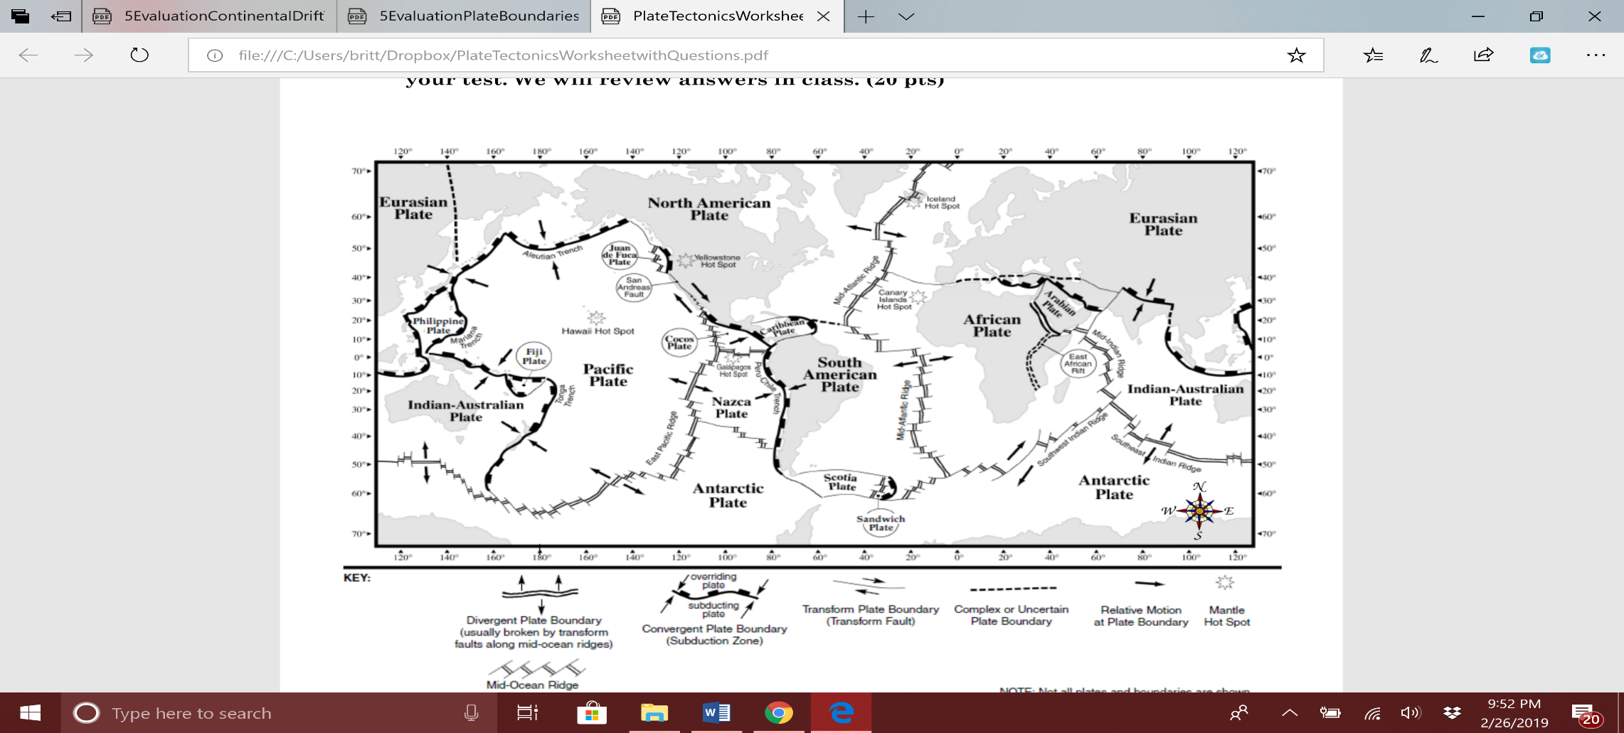Which

* 1. **Which plate is the subducting plate, the South American Plate or the Nazca Plate?**
  2. **What kind of boundary exists at the east pacific ridge?**
  3. **How are the Artic Plates and the Pacific plates moving relative to each other?**