**Topic 8 Lesson 3- Obtaining and Removing Materials from Cells**

**Student Notes**

**What is Homeostasis?**

* _________________________ is the maintenance of a constant internal state in a changing environment.
* Homeostasis ensures that cells can **____________________** and **________________**energy, **____________________** new cells,________________________materials, and **_________________________**wastes in a changing environment.
* **________________________________** organisms exchange materials directly with the environment.
* **_______________________**organisms have systems that transport materials to cells from other places **_______________________________**the organism.
  + ***Examples:*** The cardiovascular system in humans and *xylem* and *phloem* in plants are transport systems.

**How do cells exchange materials?**

**Cell Membrane and Cell Wall:**

* ____________________ cells have a __________________ _________________made of proteins and lipids
* ____________________ cells have cell membranes and ________________ ____________________ – ex: plants, fungi and bacteria

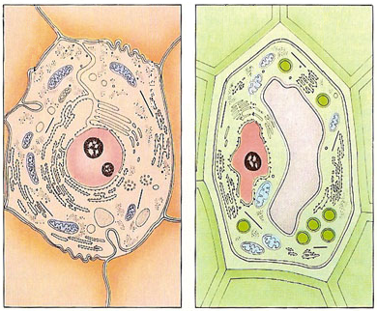

Cell Membrane

Cell Wall

**Function of the Cell Membrane:**

* Cell membrane separates the components of a cell from its _____________________—surrounds the cell
* “Gatekeeper” of the cell—regulates the flow of materials into and out of cell—_____________________ _____ _______________________________
* Cell membrane helps cells maintain _____________________—stable internal balance

**There are 2 types of transport**

**Passive Transport**

* cell **________________ _________________**  use energy
  1. **Diffusion** is the **______________________**of **____________________** particles across a selectively permeable membrane until **_________________________/** balance is reached.
     1. These particles move from an area of **_____________________ ____________________** to an area of **___________________** concentration.
  2. **Osmosis** is the _____________________of __________________r through a selectively permeable membrane
     1. Water diffuses across a membrane from an area of __________________concentration to an area of_________________ concentration

**Active Transport**

Active transport is the movement of molecules from ________________ to _________________ concentration. _____________________ ______________________ required.

* ______________________ in the cell help with this movement

Ex: Body cells must pump carbon dioxide out into the surrounding blood vessels to be carried to the lungs for exhale. Blood vessels are high in carbon dioxide compared to the cells, so energy is required to move the carbon dioxide across the cell membrane from LOW to HIGH concentration.

* **_________________________ and ___________________** is the method used for **very large molecules** (such as food and wastes) get into and out of the cell

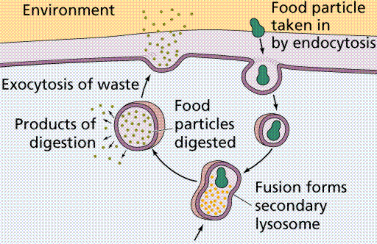

* **Food is moved __________________ the cell by _____________________________**
* **Wastes are moved _____________________ of the cell by _______________________________**

**How do organisms maintain homeostasis?**

* **Cells and whole organisms must work to maintain homeostasis in a constantly changing environment.**
* **Some animals adapt their behavior to control body temperature.**

**Examples:**

* **Trees can show seasonal responses to changes in the environment.**

**Examples:**