**Oreo Cookies and Plate Tectonics**

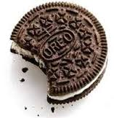Amateur geologists can simulate how plates move on the Earth’s surface.

The term **tectonics** originates from the Greek word “tektõn,” referring to a builder or architect. **Plate tectonics** suggests that large features on Earth’s surface, such as continents, ocean basins, and mountain ranges, result from interactions along the edges of large plates of Earth’s outer shell. This outer shell is called the **lithosphere** from the Greek “lithos,” meaning hard rock. The plates, composed of Earth’s crust and uppermost mantle, ride on a warmer, softer layer of the mantle, called the **asthenosphere**.

In our experiment, the upper cookie will represent the **lithosphere**, the creamy filling the **asthenosphere**, and the lower cookie the **lower mantle** . Label the Oreo Diagram below.

Creamy Filling

Upper Cookie

Plates move in three basic ways and you will use 3 cookies to model each one Let’s look at them one by one.

Lower Cookie

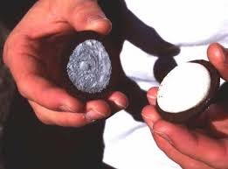Choose a cookie. **Don’t eat it…yet!**

1. First, carefully remove the upper cookie (a “twisting” motion is required).
2. Slide the upper cookie over the creamy filling. This motion simulates the movement of a rigided ________________________ plate over the softer ____________________________.
3. Next, break the upper cookie in half. As you do so, listen to the sound it makes. What does that breaking represent? ______________________________________________________________________________

Divergent Boundaries

Let’s look at divergent plate boundaries. Divergent means _____________________________________.

1. Now place the cookie on the table and slide the two pieces apart and gently push down on both halves. What happens to the creamy filling? ________________________________________________________________________
2. The creamy filling between the two broken “plates” may tend to flow upward. When two plates move apart at a divergent boundary, the magma underneath decompresses and flows upward also. This creates a __________________________________.
3. True or False. Divergent boundaries cause lots of earthquakes.
4. Put your cookie on the table and pick up a second cookie.

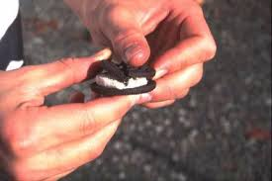Convergent boundaries

Now let’s look at convergent plate boundaries. Convergent means ______________________________.

1. Pick up cookie # 2, gently twist the top cookie off the filling and slide it over the creamy filling.
2. Break the top cookie in half.
3. Take the two cookie halves and slowly push them toward each other. What happens to the **filling** as the plates slide together? ______________________________________ ____________________________________________________________________________________________________________________________________________________________
4. What happens to the cookies as they push against each other? ___________________________
5. As one cookie (plate) moves underneath the other we call it _____________________________.

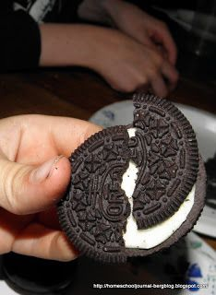*At convergent plate boundaries, the cold, brittle lithosphere extends to great depths, and* ***deep earthquakes*** *occur. The very largest earthquakes are at subduction zones where two plates get stuck together for centuries, then suddenly let go.*

Transform boundaries

1. Now let’s look at a transform plate boundary. Pick up cookie # 3, gently twist off the top cookie and slide it over the creamy filling.
2. Break your top cookie in half, place both halves back on top.
3. Try sliding the two cookie pieces laterally past one another, over the creamy filling. What do you notice about the cookie edges? _____________________________________________________________

*You can feel and hear that the “plates” do not slide smoothly past one another, but rather* ***stick then let go, stick then let go****. The cracking sound you hear each time is like an earthquake occurring along the San Andreas Fault in California.*

1. True or False. Transform Boundaries are very geologically active, causing many earthquakes.

**Plate Boundaries**

Name __________________________________

Fill in the chart below. Use your **plate boundaries notes**  if you need help.

|  |  |  |  |
| --- | --- | --- | --- |
| **Boundary Type** | **Draw what the Oreo Looked like** | **Movement of the Plates (Directions)** | **Resulting Landform or Geologic Activity** |
| **Transform** |  |  |  |
| **Divergent** |  |  |  |
| **Convergent:**  **Continent – Continent** |  |  |  |
| **Convergent:**  **Continent – Oceanic** |  |  |  |
| **Convergent:**  **Oceanic – Oceanic** |  |  |  |