Question: What plant helped Gregor Mendel discover genes?

THE WORK OF GREGOR MENDEL
Genetics — is the scientific study of heredity
Heredity — the passing on of characteristics from parents to offspring. These characteristics are called traits.
Gregor Mendel, an Austrian monk, discovered important facts about heredity using garden peas.
Garden peas produce male and female sex cells called gametes. Fertilization occurs when the male and female reproductive cells join forming a zygote. The zygote becomes part of a seed.
Mendel used true-breeding peas, meaning if they were allowed self self-pollinate, they would produce offspring identical to themselves.
Mendel studied seven traits of pea plants, but only studied ONE trait at a time, for example to see how height was passed from parent to offspring. Mendel took pollen from a true- breeding tall pea plant and cross-pollinated a true-breeding short pea plant.
Hybrid — offspring of parents that have different forms of a trait. Since only one trait was different the offspring is called a monohybrid.
Parents | Offspring | Offspring of F1 generation
P1 generation | F1 generation | F2 generation

Page 1 of 5

Question: What are different forms of genes called?

MENDEL’S LAWS OF HEREDITY
Mendel concluded that biological inheritance is determined by factors that are passed from one generation to the next. These factors that determine traits are called genes.
Alleles — different forms of genes, such as genes for height can either produce genes for tall plants or genes for short plants.
1ST LAW
Law of Segregation — every organism has two alleles of each gene and when gametes are produced the alleles separate.
Phenotype — the way an organism looks and behaves (tall or short)
Genotype — the allele combination of an organism (TT, tt, Tt)
An organism is homozygous for a trait if the two alleles for the trait is the same.
(TT — homozygous dominant; tt — homozygous recessive)
An organism is heterozygous for a trait if its two for the trait are different (Tt).
2ND LAW
Law of Independent Assortment — genes for different traits are inherited independently of each other.
*In a dihybrid cross (two traits) you can see both of Mendel’s Laws
at work.
Page 2 of 5

Question: How can Punnett squares be used to determine the probability of genotype and phenotype?

PUNNETT SQUARES
Reginald Punnett came up with Punnett Squares to predict the proportions of possible genotypes in offspring.
one parent’s genotype T t
one parent’s t |  |  |  |  |  | Punnett square for a single
genotype t |  |  |  |  |  | trait |  | single trait
Monohybrid Cross: Heterozygous Plants
Parent 1 X Parent 2 |  |  | Crossing two pea plants that are heterozygous for seed color (Tt) will produce offspring in the following ratio:
Tt T t Tt |  |  | 1/4 = TT (Homozygous Dominant)
T TT Tt |  |  | 2/4 = Tt (Heterozygous)
 |  |  | 1/4 = (Homozygous recessive)
t Tt tt
Monohybrid Cross: Homozygous Plants
A cross between a yellow |  |  |  |  | Parent 1 X Parent 2
homozygous plant (TT) with a |  |  |  |  | TT t t tt
homozygous recessive green plant |  |  |  |  | T Tt Tt
(tt) only produces heterozygous
yellow (Tt) offspring. |  |  |  |  | T Tt Tt
 |  |  |  |  | 4/4= Tt (Heterozygous)
*A Punnett square can also be created for dihybrid crosses — it would be four boxes wide and four boxes tall.
Page 3 of 5
Question: If humans have a diploid number of 46 chromosomes, what is the haploid number of chromosomes?

MEIOSIS
Meiosis — a type of cell division that produces four cells, each with half the number of chromosomes as the parent cell.
In animals, meiosis occurs in the sex organs — the testes in males and the ovaries in females.
A gamete, or sex cell is a haploid cell, meaning this cell contains only one of each kind of chromosomes versus a diploid cell found in body cells, which have two of each kind of chromosome.
*Mitosis results in the production of two genetically identical diploid cells, whereas meiosis produces four genetically different haploid cells in two stages known as the 1st and 2nd meiotic divisions.
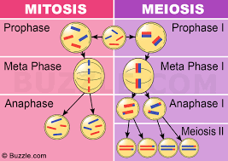

How are Meiosis and Mitosis alike ? How are Meiosis and Mitosis Different?

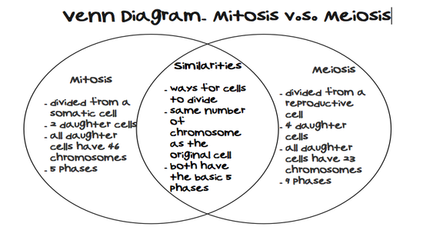
Page 5 of 5

