**Topic 4 Lesson 1 “ Fluids On The Move”- Convection Currents**

***Read the background information and view the video in your online textbook under “ Topic 4 Lesson 1- Interactivity: Fluids on the move”. Use the information answer the questions below*.**

1. **Use a cause-and-effect relationship to explain why a convection current forms when hot rocks and cold rocks are placed in a tank of water. (4 Points)**
2. **The tank, water, and rock packages were the parts of this model. What part represented Earth's atmosphere and what part represented Earth's surface? (2 Points)**
3. **What is the role of the sun in forming convection currents in Earths water and air? (2 Points)**
4. 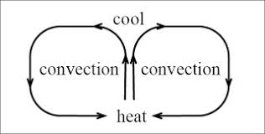**Construct an explanation based on evidence from the model you saw in the video and from our lab demonstrations, for how convection currents might form in the atmosphere. (2 Points)**