Egg Osmosis Lab

Introduction:

Cells have an outer covering called the cell membrane. This membrane is selectively permeable; it has tiny pores or holes that allow objects to move across it. The cell membrane controls what moves in and out of the cell. Food and oxygen move into cells across the cell membrane through the process of diffusion. Diffusion is movement of a substance from an area of high concentration to an area of low concentration. Osmosis is a special type of diffusion; it is the diffusion of water across a selectively permeable membrane. Osmosis occurs when water moves from an area where it is more concentrated to an area where it is less concentrated.

In this lab you will be using an egg with the shell removed. The shell-less egg will represent a cell and its selectively permeable membrane. You will remove the shell of the egg by soaking the egg in vinegar. The egg shell is made up of the mineral calcium carbonate. Calcium carbonate dissolves in acids such as vinegar. During this process it releases the gas carbon dioxide. After the shell has been dissolved, only the membrane will remain around the egg.

Safety notes:
1. Raw eggs can carry salmonella (harmful bacteria). Be sure to wash your hands after handling the eggs.
2. Handle your egg very carefully so that it does not break

Pre lab Questions:
1. What do you think would happen to a shell-less egg if water passed into the egg through the membrane?

2. What do you think would happen to a shell-less egg if water passed out of the egg through the membrane?

3. What substance must pass through the shell and membrane in order for a chick to develop correctly?

4. What would happen to the developing chick if the egg membrane did not work correctly?

Purpose:
To soak an egg in various liquids and observe how the size of the egg changes as it gains or loses water through the membrane.

Materials:
Raw eggs, 300 ml vinegar, tap water, salt water, and a liquid of your choice, metric tape, balance, plastic container to hold egg, beaker, marker, masking tape

Hypothesis:
Predict how eggs will respond when it is soaked in:
1. Vinegar:
2. Distilled Water
3. Corn Syrup
4. Salt Water

Procedure Step 1: Soaking egg in vinegar

1. Label your container with your section and table number.
2. In the data table, make a drawing and observation of the eggs in the appropriate space
3. To Measure Your Eggs, use a flexible tape measure, measure the circumference of the egg (along the “equator”). Record circumference to closest millimeter
4. Weigh the eggs in grams. Record mass
5. Pour 300 ml of vinegar into the container.
6. Carefully place eggs into the container and allow it to soak 2 days. Loosely place lid on top; if placed too tight it may break!
7. Put your container in the designated space.
8. Clean up materials and wash your hands.
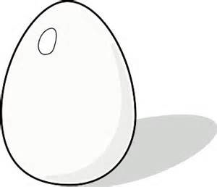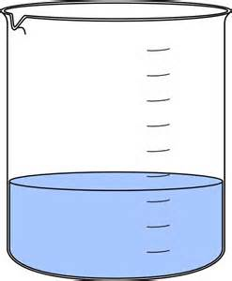 Vinegar

Procedure Step 2: Soaking egg in distilled water, corn syrup, salt water

1. Carefully remove eggs from the container of vinegar.
2. Remove any remaining bits of shell by gently running eggs under water. Blot it dry with a paper towel
3. Measure and mass your eggs and record observations in data table
4. Pour used vinegar down the drain. Rinse container
5. Place 3 eggs in separate liquids: distilled water, corn syrup, salt water
6. Allow each egg to soak 2 days
7. Put containers in designated space, clean up materials and wash your hands.

Distilled Water Corn Syrup Salt Water

Data Tables

Name: ____________________________________________________

Procedure 1 - Data Table: Egg in Vinegar

Egg | Circumference | Initial  Mass (g) | Final Mass (g) after vinegar | % Weight Change  Initial/Final x 100 | Observations
1
2
3

Procedure 2 – Data Table: Egg in Distilled Water, Salt Water, Corn Syrup

Liquid | Initial Mass (g) | Final Mass (g) after soaking | Observations | % Weight Change  Initial/Final x 100
Distilled Water

Salt Water

Corn Syrup

Analysis Questions

1. What liquids caused the egg to swell? Cite evidence from your data table.

2. What liquids caused the egg to shrink? Cite evidence from your data table.

3. What process caused the egg to swell or shrink? Illustrate this process below.

