1. Which of the following statements explains the energy budget on Earth?
A. Most energy is made into food by plants.
B. Earth's surface absorbs and re-emits equal amounts of energy.
C. Earth's surface reflects more energy than the atmosphere.
D. The atmosphere absorbs more energy than Earth's surface.
2. What type of heat transfer takes place from the sun to Earth?
A. convection
B. conduction
C. expansion
D. radiation

Circle the phrases that correctly complete the paragraph.

3. The greenhouse effect supports life on Earth. It is caused when energy from the sun is (absorbed by oceans / trapped by the atmosphere / reflected by the atmosphere / reflected from Earth). If the concentration of carbon dioxide gas continues to increase, it will cause (temperatures to increase / temperatures to decrease / sea levels to decrease / increased glaciers) on Earth.
4. As an experiment, Bertie made wax candles. He used a heat transfer process to melt the wax in a pot on the stove. Throughout the candle-making experiment, he took several measurements. He used the data to construct a graph showing the temperature change of a sample of wax. Which two items describe what is happening to the wax sample over time?
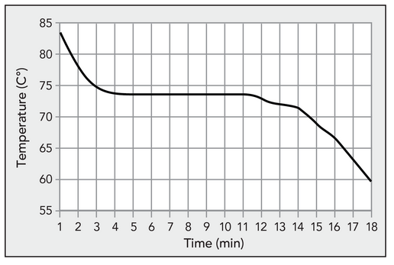
A. Temperature is increasing.
B. Temperature is decreasing.
C. Thermal energy is increasing.
D. Thermal energy is decreasing.

5. There are several ways to transfer heat to cook food. Read each example in the word bank of how heat is transferred in the kitchen. Use the graphic organizer to classify phrase into the correct column.

boils water • melts butter in a hot pan • microwaves chocolate cake • heats a tortilla in a pan on the stove • toasts a marshmallow over an open flame
• heats apple cider until steam rises from the pot

Conduction | Convection | Radiation
heats a tortilla in a pan on the stove  melts butter in a hot pan | boils water  heats apple cider until steam rises from the pot | microwaves chocolate cake  toasts a marshmallow over an open flame

6. Name the 5 layers of the atmosphere from the bottom to the top. Describe each layer in your own words.
Exosphere Top, Thermosphere, Mesosphere, Stratosphere, Troposphere Bottom
7. Define atmosphere and Give 3 examples of what the atmosphere does for the earth
Atmosphere is a layer of gases that surround the earth. Protects and supports life Absorbs energy from sun Protects life from high energy radiation and frigid vacuum of space Recycles water and other chemicals
- Answers may vary
8. List the composition of the atmosphere and the percentage of each gas.

9. Which gas is used by green plants? Carbon Dioxide
10. Which gas is produced by green plants? Oxygen
11. Using vocabulary words, explain why your ears pop as you start to descend in an airplane. Answers will vary
12. Atmospheric pressure ______Decreases_________ with an increase in altitude.
13. The density of the atmosphere ___Increases___ with a decrease in altitude.
14. List 3 ways that solar radiation is sent back into space
Reflected by clouds, Absorbed by atmosphere and clouds, Scattered by atmosphere, Reflected by earth’s surface

15. Name 4 types of clouds and draw a picture of each
All Clouds names below and pictures will vary
High Clouds- Cirrus, Currocumulus, Cirrostratus
Middle Clouds- Altocumulus, Altostratus, Cumulonimbus
Low Clouds- Stratus, stratocumulus, Cumulus, Nimbostratus
16. What layer of the atmosphere is the ozone layer found? Describe how the ozone layer protects the earth
Atmosphere layer called the stratosphere; Ozone gas (O3) absorb solar radiation Releases it as heat Protects earth from harmful UV rays
17. Which layer of the atmosphere would the space shuttle orbit? Thermosphere
18. In what layer of the atmosphere does weather occur? Troposphere
19. What layer is known as the “heat layer”? Thermosphere
20. Use the following words to talk about water vapor in the atmosphere.
HUMIDITY, DEW Point, Clouds, Condense, Water Cycle – Answers will vary

