Study Guide- Energy in the Ocean and Atmosphere

52 Points Total- Homework Grade

Due on Thursday 4/11/2019; Test Date Thursday 4/11/19

1. Define the following and give an example **(3 Points):** **( Topic 4 Lesson 1 Page 156)**
   1. Conduction:
   2. Convection:
   3. Radiation:
2. Circle examples of radiation in the passage below **(2 Points). ( Topic 4 Lesson 1 Page 156)**

A chemist working in a laboratory is investigating the thermal energy of H2O in a solid, liquid, and gas state. First, she places ice in a pan on a burner and heats it. She records the temperature at which the solid ice melts. Next, she takes the liquid water and heats it in a microwave. The liquid begins to bubble and evaporate into a gas. She records the temperature at which the liquid water turned into a gas.

1. **What causes wind. Be specific and use vocabulary words (3 Points). ( Topic 4 Lesson 2 Page 161)**
2. What two factors influence global wind patterns? (2 Points) (Topic 4 Lesson 2 Page 163-164)
3. What phenomenon explains why global winds do not move in a straight path? Explain. **( 2 Points) (Topic 4 Lesson 2 Page 165)**
4. Helena is making a computer model to compare warm and cold surface currents. She wants to explain how they affect the climate of different locations. Helena should explain that cold surface currents **(are less dense than warm currents / cool the air above them / make the climate warm and wet / warm the air above them),** while warm surface currents **(are more dense than cold currents / warm the air above them / cool the air above them / make the climate cool and dry). (2 Points) (Topic 4 Lesson 2 Page 166)**
5. Jet streams are winds that can travel up to 400 kilometers per hour. A jet stream can have an extremely powerful effect on the weather. Which of these explains how jet streams can affect weather in the United States? Choose the three that apply. (3 Points) **(Topic 4 Lesson 2 Page 167)**

A. cause warmer temperatures

B. cause precipitation

C. cause temperatures to remain the same

D. cause cooler temperatures

1. List the layers of the atmosphere AND describe what can be found there. Use your “ blue layers of the atmosphere graphic organizer we did in class. Example- we live in the troposphere. **(3 Points) Utilize your “Layer of the atmosphere “ foldable for this, along with your atmosphere notes.**
2. Look at the map below. Predict what will happen in Florida due to the jet stream. Circle the correct answer. (1 Point) **(Topic 4 Lesson 2 Page 167)**

A. cooler temperature

B. sea breeze

C. warmer temperature

D. land breeze

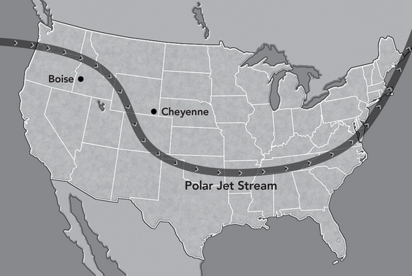

1. Use the graphic organizer to classify each description of local and global wind patterns. (3 Points) **(Topic 4 Lesson 2 Page 163-167)**

**land breezes • trade winds • prevailing westerlies • polar easterlies**

**• sea breezes • jet streams**

|  |  |
| --- | --- |
| Global Wind | Local Wind |
|  |  |

1. What causes the pattern of ocean currents to change during La Niña and El Niño events? (1 Point) **(Topic 4 Lesson 3 Page 174)**
2. Name the tool you would use to measure wind speed? **(1 Point) (Topic 3 Lesson 2 Page 162)**
3. Name the tool you would use to measure air pressure. **(1 Point) (Topic 3 Lesson 2 Page 162)**
4. Use the graphic organizer and the word bank to place each description of deep currents and surface currents into the correct column. (2 Points) **(Topic 4 Lesson 3 Page 171-176)**

-movement of ocean water caused by wind

-movement of cold ocean water

-movement of ocean water that causes La Niña events

-movement of ocean water caused by differences in density

|  |  |
| --- | --- |
| Deep Currents | Surface Currents |
|  |  |

1. What is the name of the phenomenon by which gases such as water vapor and carbon dioxide hold energy in the Atmosphere to keep Earth Warm**? (1 Point) The greenhouse effect**
2. What is the driving force that causes Land and sea breezes? **(1 Point)Topic 4 Lesson 2 Page 163**

**

1. *Label each diagram to the right, with the correct terms* ***(3 Points)***

**Topic 4 Lesson 2 Page 163**

* 1. *Land Breeze*
  2. *Sea Breeze*
  3. *High Pressure*
  4. *Low Pressure*
  5. *Add Sun*
  6. *Add Moon*

1. Define and fully explain the following **(4 Points)**

**Topic 4 Lesson 2 Page 163**

* 1. Land Breeze
  2. Sea breeze:

1. *What happens to air when its heated?* ***(1 Point)***
2. *What happens to air when its cooled?* ***(1 Points)***
3. *Wind always flows from an area of ________________ Pressure to an area of _______________ pressure .* ***(2 Points)***
4. *Label the Global winds diagram using the labels below. Be sure to include the convection current/ wind cells on the outer perimeter and the missing arrows at the poles. (****10 Points) Topic 4 Lesson 2 Page 166***

*Prevailing westerlies Northeast trades Southeast trades polar easterlies doldrums Horse Latitudes*

