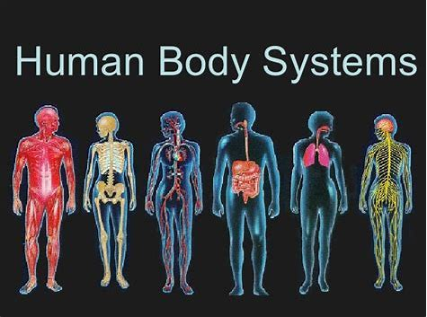

Students have been assigned and **Extra Credit** project to create a 3d model of their assigned body system.

This Project is **Due Monday December 17, 2018.** On this day students will present their project to their classmates. The classroom will be a virtual body systems museum and learning clinic.

**To Earn Extra Credit:** Create a 3-D Model or poster of your assigned body system: MAX is 20 Points

**Grading:**

* Title and Name -**1.5 points**
* Major organs and parts must be labeled in your body system - **5 points**
* Placed in an outline or shell of a body **2.5 points**
* Organs are in anatomically correct locations **6 points**
* Neat, easy to understand colorful and creative **5 points**