Student Name:_______________________________ HR Teacher:_________________________

Back to School Dance Agreement and Permission Letter

6th Grade Dance

Dear Parents/Guardians and Students of RAA Middle School,
RAA SGA is sponsoring our Neon Lights Back to School Dance on Thursday, October 26th, 2017. The dance will be held in the school gym from 6:30 – 8:30 p.m.. There will be music from our LIVE DJ. Light refreshments and Glow Sticks will also be sold by our PTO. Tickets (color-coded wristbands) are $5 and will be on sale before school in the Pay Station in Front of the Media Center ONLY ON MONDAY,TUESDAY, AND WEDNESDAY OCTOBER 23RD - 25th. Wristbands will be distributed during homeroom on the day of the dance.

GUIDELINES
Tickets
- The deadline to purchase ticket is Wednesday October 25 @10am
- RAA students will be able to purchase tickets if they have no ISD or OSS for the month of October.
- Students must have this letter signed by the parent/guardian in order to buy their ticket.
- Have the signed letter with you when you come to buy your ticket. We will keep it, and give you a copy of the dance rules when you buy the ticket. The signatures show us that you agree to follow the guidelines.
- No tickets will be sold at the door. Students must be wearing the wristband to enter. There will be a list of students who have purchased tickets at the door and the name on the wristband must be on that list.

Drop-Off and Pick-Up
- Students attending the dance will be admitted ONLY through the Front Office Gates Leading to the Gym
- Bring ONLY personal items you can secure. There will be no locked storage for personal items.
- No one should walk across the campus from any other entry point.
- Students are to be picked up from the dance between 8:30 and 8:45 p.m. at Tharpe Street Parent Pick-up Area. Students will not be allowed to walk across campus to any other pick-up point after the dance.
- Students will not be allowed to leave the gym before the end of the dance unless a parent comes to the door of the Gym to pick up their child.

Citizenship
- Inappropriate dancing, jumping, running, etc. will not be tolerated. Parents will be called to pick up students who do not cooperate with school officials.

Dress Code
- The theme for the Dance is NEON LIGHTS!! For the dance, clothes should be casual but still in school dress code; however, distressed jeans may be worn . Students will not be permitted to change clothes at the dance.

Jan Bennitt and Tim Girard, SGA Sponsors

Parent Name:

_______________________________ __________________________
Parent Signature Emergency Phone # For Dance

6th Grade Dance Info and Wristband Receipt for 10/26/17 Dance
Tickets
- If you have an ISD/OSS for October you will not be able to enter the dance.
- No tickets will be sold at the door. Students must be wearing the wristband to enter. There will be a list of students who have purchased tickets at the door and the name on the wristband must be on that list.

Drop-Off and Pick-Up
- Students attending the dance will be admitted ONLY through the Front Office Gates Leading to the Gym
- Bring ONLY personal items you can secure. There will be no locked storage for personal items.
- No one should walk across the campus from any other entry point.
- Students are to be picked up from the dance between 8:30 and 8:45 p.m. at Tharpe Street Parent Pick-up Area. Students will not be allowed to walk across campus to any other pick-up point after the dance.
- Students will not be allowed to leave the gym before the end of the dance unless a parent comes to the door of the Gym to pick up their child.

Citizenship
- Inappropriate dancing, jumping, running, etc. will not be tolerated. Parents will be called to pick up students who do not cooperate with school officials.

Dress Code
- The theme for the Dance is NEON LIGHTS!! For the dance, clothes should be casual but still in school dress code; however, distressed jeans may be worn. Students will not be permitted to change clothes at the dance.

6th Grade Dance Info and Wristband Receipt for 10/26/17 Dance
Tickets
- If you have an ISD/OSS for October you will not be able to enter the dance.
- No tickets will be sold at the door. Students must be wearing the wristband to enter. There will be a list of students who have purchased tickets at the door and the name on the wristband must be on that list.

Drop-Off and Pick-Up
- Students attending the dance will be admitted ONLY through the Front Office Gates Leading to the Gym
- Bring ONLY personal items you can secure. There will be no locked storage for personal items.
- No one should walk across the campus from any other entry point.
- Students are to be picked up from the dance between 8:30 and 8:45 p.m. at Tharpe Street Parent Pick-up Area. Students will not be allowed to walk across campus to any other pick-up point after the dance.
- Students will not be allowed to leave the gym before the end of the dance unless a parent comes to the door of the Gym to pick up their child.

Citizenship
- Inappropriate dancing, jumping, running, etc. will not be tolerated. Parents will be called to pick up students who do not cooperate with school officials.

Dress Code
- The theme for the Dance is NEON LIGHTS!! For the dance, clothes should be casual but still in school dress code; however, distressed jeans may be worn. Students will not be permitted to change clothes at the dance.

Student Name:_______________________________ HR Teacher:_________________________

Back to School Dance Agreement and Permission Letter
7th & 8th Grade Dance

Dear Parents/Guardians and Students of RAA Middle School,
RAA SGA is sponsoring our Neon Lights Back to School Dance on Friday, October 27th, 2017. The dance will be held in the school gym from 6:30 – 8:30 p.m.. There will be music from our LIVE DJ. Light refreshments and Glow Sticks will also be sold by our PTO. Tickets (color-coded wristbands) are $5 and will be on sale before school in the Pay Station in Front of the Media Center ONLY ON MONDAY,TUESDAY, AND WEDNESDAY OCTOBER 23RD - 25th. Wristbands will be distributed during homeroom on the day of the dance.

GUIDELINES
Tickets
- The deadline to purchase ticket is Wednesday October 25 @10am
- RAA students will be able to purchase tickets if they have no ISD or OSS for the month of October.
- Students must have this letter signed by the parent/guardian in order to buy their ticket.
- Have the signed letter with you when you come to buy your ticket. We will keep it, and give you a copy of the dance rules when you buy the ticket. The signatures show us that you agree to follow the guidelines.
- No tickets will be sold at the door. Students must be wearing the wristband to enter. There will be a list of students who have purchased tickets at the door and the name on the wristband must be on that list.

Drop-Off and Pick-Up
- Students attending the dance will be admitted ONLY through the Front Office Gates Leading to the Gym
- Bring ONLY personal items you can secure. There will be no locked storage for personal items.
- No one should walk across the campus from any other entry point.
- Students are to be picked up from the dance between 8:30 and 8:45 p.m. at Tharpe Street Parent Pick-up Area. Students will not be allowed to walk across campus to any other pick-up point after the dance.
- Students will not be allowed to leave the gym before the end of the dance unless a parent comes to the door of the Gym to pick up their child.

Citizenship
- Inappropriate dancing, jumping, running, etc. will not be tolerated. Parents will be called to pick up students who do not cooperate with school officials.

Dress Code
- The theme for the Dance is NEON LIGHTS!! For the dance, clothes should be casual but still in school dress code; however, distressed jeans may be worn . Students will not be permitted to change clothes at the dance.

Jan Bennitt and Tim Girard, SGA Sponsors

Parent Name:

_______________________________ __________________________
Parent Signature Emergency Phone # For Dance

7th & 8th Grade Dance Info and Wristband Receipt for 10/27/17 Dance
Tickets
- If you have an ISD/OSS for October you will not be able to enter the dance.
- No tickets will be sold at the door. Students must be wearing the wristband to enter. There will be a list of students who have purchased tickets at the door and the name on the wristband must be on that list.

Drop-Off and Pick-Up
- Students attending the dance will be admitted ONLY through the Front Office Gates Leading to the Gym
- Bring ONLY personal items you can secure. There will be no locked storage for personal items.
- No one should walk across the campus from any other entry point.
- Students are to be picked up from the dance between 8:30 and 8:45 p.m. at Tharpe Street Parent Pick-up Area. Students will not be allowed to walk across campus to any other pick-up point after the dance.
- Students will not be allowed to leave the gym before the end of the dance unless a parent comes to the door of the Gym to pick up their child.

Citizenship
- Inappropriate dancing, jumping, running, etc. will not be tolerated. Parents will be called to pick up students who do not cooperate with school officials.

Dress Code
- The theme for the Dance is NEON LIGHTS!! For the dance, clothes should be casual but still in school dress code; however, distressed jeans may be worn. Students will not be permitted to change clothes at the dance.

7th & 8th Grade Dance Info and Wristband Receipt for 10/27/17 Dance
Tickets
- If you have an ISD/OSS for October you will not be able to enter the dance.
- No tickets will be sold at the door. Students must be wearing the wristband to enter. There will be a list of students who have purchased tickets at the door and the name on the wristband must be on that list.

Drop-Off and Pick-Up
- Students attending the dance will be admitted ONLY through the Front Office Gates Leading to the Gym
- Bring ONLY personal items you can secure. There will be no locked storage for personal items.
- No one should walk across the campus from any other entry point.
- Students are to be picked up from the dance between 8:30 and 8:45 p.m. at Tharpe Street Parent Pick-up Area. Students will not be allowed to walk across campus to any other pick-up point after the dance.
- Students will not be allowed to leave the gym before the end of the dance unless a parent comes to the door of the Gym to pick up their child.

Citizenship
- Inappropriate dancing, jumping, running, etc. will not be tolerated. Parents will be called to pick up students who do not cooperate with school officials.

Dress Code
- The theme for the Dance is NEON LIGHTS!! For the dance, clothes should be casual but still in school dress code; however, distressed jeans may be worn. Students will not be permitted to change clothes at the dance.

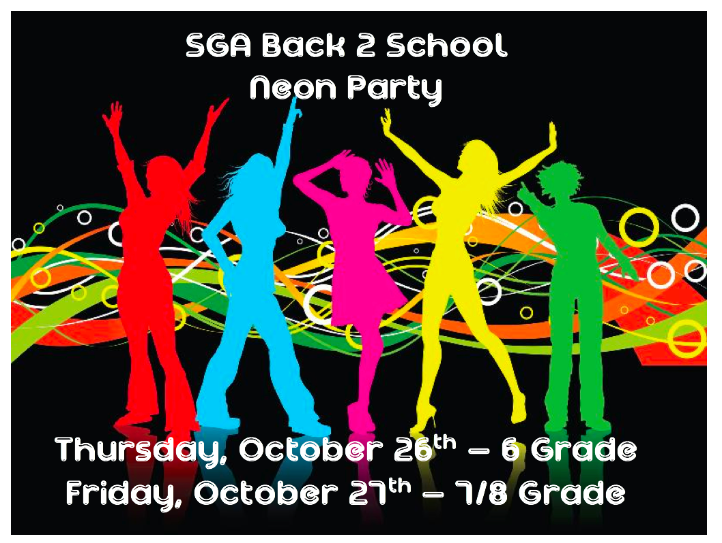
SGA Back 2 School
Neon Party

