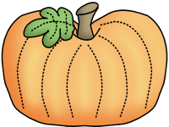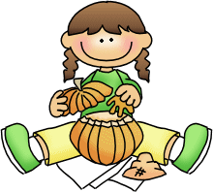

**Savvas Reading-** **Unit 1 Week 4**

***Theme: What is fun about exploring new places?***

***Letter Recognition & Sounds:***

Nn and Short Ii

***Sight Words:*** my, we, make, as

***Vocabulary:***

chasing, scrambles, follows, slips

***Genre:*** Realistic Fiction

***Language and Conventions:***

Plural Nouns

**Math-**

***Chapter 3: Represent, Count, Read, and Write Numbers 6-9***

The Chapter 3 Test will be **Friday, October the 7th**. I do not need the homework packet returned.

**Science-**

Apples/Trees/Our Five Senses

Please visit the Parent Conferences link on my website to schedule your conference. I am looking forward to meeting with families!

**Friday, 9/30**

Wear **GOLD** for Pediatric

Cancer awareness!

**Monday, 10/3**

Fire Department visits school for Fire Safety lesson and for us to see the fire trucks and equipment!

**Friday, 10/14**

End of the First Nine Weeks

**Monday, 10/17**

**Teacher Planning Day (No School)**

**Friday, 10/28**

Field Trip to Aunt Louise’s Farm

Wear red class t-shirt!

**Monday, 10/31**

Fall Celebration (information coming home soon)



**Classroom Needs**

I am collecting outside toys for our playground time. If you are willing to donate a soccer ball or sidewalk chalk for our class, it would be greatly appreciated! I would also like to replenish our treasure chest with prizes. They can be found at the Dollar Tree or recycled Happy Meal toys will work too. Thank you!

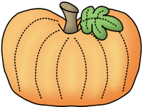

**Peyton**



**Sonja Darden’s Kindergarten Class**

**Buck Lake Elementary** 488-6133 [dardens@leonschools.net](mailto:dardens@leonschools.net)

**September 27, 2022**

