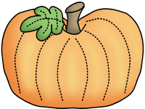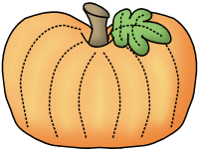

Our trip to Aunt Louise’s Farm is this Tuesday! Please plan to send a lunch and drink with your child and have them wear their red class shirt and comfortable shoes!



**Savvas Reading-** **Unit 1 Week 4**

***Theme: What is fun about exploring new places?***

***Letter Recognition & Sounds:***

Nn and Short Ii

***Sight Words:*** my, we, make, as

***Vocabulary:***

chasing, scrambles, follows, slips

***Genre:*** Realistic Fiction

***Language and Conventions:***

Plural Nouns

**Math- *Chapter 3:***

***Count and Represent Numbers Through 9***

The Chapter 4 Test will be **Monday, October the 23rd**. I do not need the homework packet returned.

**Science-**

Autumn

**Tuesday, 10/10**

* Field Trip to Aunt Louise’s Farm
* Health Screenings

**Friday 10/13** End of 9 Weeks

**Monday, 10/16**

**Teacher Planning Day (No School)**

**Wednesday, 10/18** Picture Retakes

**10/23-11/3**

Boosterthon Fun Run Collections

**Wednesday, 10/25**

50th Day of School (Dress in 50’s wear!)

**Tuesday, 10/31**

Fall Party and Favorite Book Character Dress Up Day

**Friday, 11/3** Fun Run!

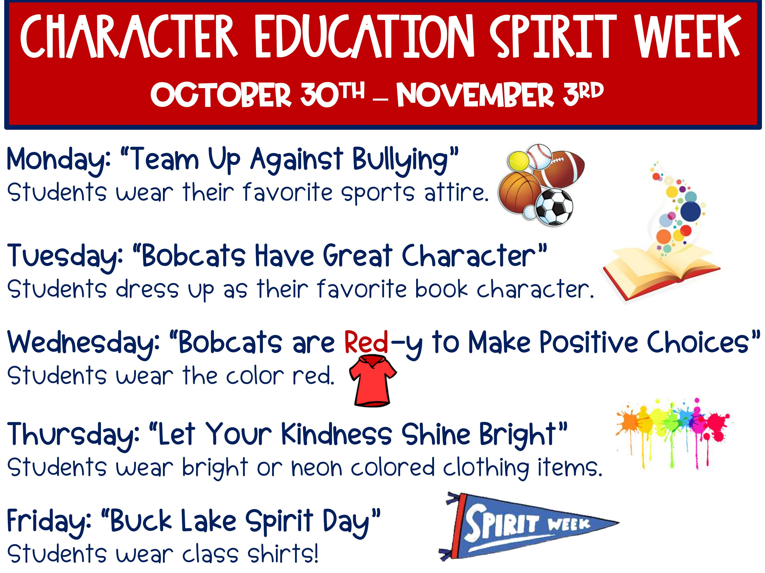

**Sonja Darden’s Kindergarten Class**

**Buck Lake Elementary** 488-6133 [dardens@leonschools.net](mailto:dardens@leonschools.net)

**October 9, 2023**

