

**THANK YOU!!!**

A HUGE thank you to all of the parents who volunteered on our field trip to the farm! It was loads of fun!

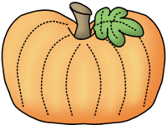

**Friday, November 4th**

**Boosterthon Fun Run at 9:00!** *Please have your child wear our red class t-shirt & tennis shoes and bring their water bottle.* Parents are invited to watch the event. The kids are very excited! Thank you so much to everyone involved in getting pledges. I really appreciate it!

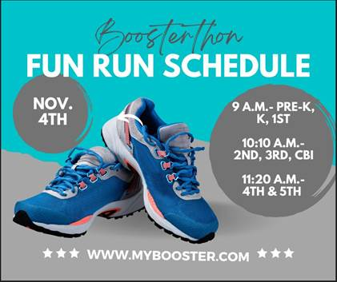

**Friday, November 11th**

Veterans Day (No School)

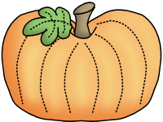

**Savvas Reading-** **Unit 2 Week 3**

***Unit Question:***

What do living things need?

***Focus:*** How do we know what we need?

***Text: Do We Need This?***

***Letter Recognition & Sounds:***

Hh and Ll

***Sight Words:*** one, two, three, did

***Vocabulary:*** water, food, shelter

***Genre:*** Fiction

* Main idea/details
* Characters

***Language and Conventions:***

Verbs

**Math- *Chapter 5: Addition***

***The Chapter 5 test is scheduled for Thursday, November 17th.*** I do not need the homework packet returned.

**Social Studies-**

Needs and Wants

Character Education Spirit Week is this week! Please visit my website for the dress up days!



**Maryum**



**Sonja Darden’s Kindergarten Class**

**Buck Lake Elementary** 488-6133 [dardens@leonschools.net](mailto:dardens@leonschools.net)

**October 31, 2022**

