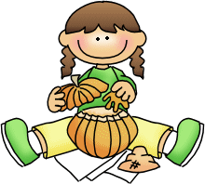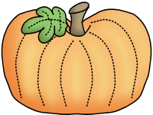

**Monday, 10/24**

Boosterthon Kick-off

**Wednesday, 10/26**

Report Cards Posted at noon

**Friday, 10/28**

Field Trip to Aunt Louise’s Farm

Wear red class t-shirt and send a lunch and drink!

**Monday, 10/31**

Fall Celebration



**THANK YOU!!!**

A HUGE thank you to all of the families who sent in playground toys and treasure chest treats! I really appreciate the donations!

**Savvas Reading-** **Unit 2 Week 2**

***Unit Question:***

What do living things need?

***Focus:*** How do some living things make what they need?

***Text: From Nectar to Honey***

***Letter Recognition & Sounds:*** Oo and Ff

***Sight Words:*** do, you, they, his

***Vocabulary:***

Bees, honey, nectar, hive

***Genre:*** Informational Text

* Main idea/details
* Make inferences

***Language and Conventions:***

Adjectives and Articles

**Math-**

***Chapter 4: Represent and Compare Numbers to 10***

***New Date:*** The Chapter 4 Test will now be **Wednesday, October the 26th**. I do not need the homework packet returned.

**Science-**

Living Things/Plant Needs

bees and pumpkins

Character Education Spirit Week will be October 31st- November 4th. Please visit my website for the dress up days!

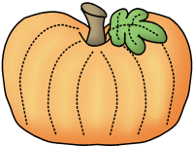

**Brian**



**Sonja Darden’s Kindergarten Class**

**Buck Lake Elementary** 488-6133 [dardens@leonschools.net](mailto:dardens@leonschools.net)

**October 24, 2022**

