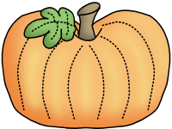

**Tuesday, 10/18**

* Health Screenings
* PTO Homeroom Parent Meeting @5:30pm in Cafeteria

**Wednesday, 10/19**

Fall Picture Retakes

**Thursday, 10/20** Wear **BLUE** for Bully Prevention Month

**Friday, 10/21**

50th Day of School Fun! Wear your fifties clothing to school!

**Monday, 10/24** Boosterthon Kick-off

**Wednesday, 10/26**

Report Cards Posted at noon

**Friday, 10/28**

Field Trip to Aunt Louise’s Farm

Wear red class t-shirt and send a lunch and drink!

**Monday, 10/31**

Fall Celebration (See information on the back of this page.)



**THANK YOU!!!**

A HUGE thank you to all of the families who sent in playground toys and treasure chest treats! I really appreciate the donations!

**Savvas Reading-** **Unit 2 Week 1**

***Unit Question:***

What do living things need?

***Focus:*** Why do some animals move from place to place?

***Text: Animals on the Move***

***Letter Recognition & Sounds:*** Dd and Kk

***Sight Words:*** are, that, of, in

***Vocabulary:***

butterflies, geese, whales

***Genre:*** Informational Text

* Main idea/details
* Make inferences

***Language and Conventions:***

Adjectives and Articles

**Math-**

***Chapter 4: Represent and Compare Numbers to 10***

The Chapter 4 Test will be **Friday, October the 21st**. I do not need the homework packet returned.

**Science-**

Living Things

**Social Studies-** Bats

Character Education Spirit Week will be October 31st- November 4th. Please visit my website for the dress up days!

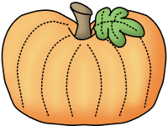

**Brian**



**Sonja Darden’s Kindergarten Class**

**Buck Lake Elementary** 488-6133 [dardens@leonschools.net](mailto:dardens@leonschools.net)

**October 17, 2022**

