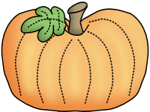

**Friday, 10/14**

End of the First Nine Weeks

**Monday, 10/17**

**Teacher Planning Day (No School)**

**Tuesday, 10/18**

* Health Screenings
* PTO Homeroom Parent Meeting @5:30pm

**Tuesday, 10/19** Fall Picture Retakes

**Friday, 10/21**

50th Day of School Fun! Wear your fifties clothing to school!

**Monday, 10/24** Boosterthon Kick-off

**Friday, 10/28**

Field Trip to Aunt Louise’s Farm

Wear red class t-shirt and send a lunch and drink!

**Monday, 10/31**

Fall Celebration (information coming home soon)



**THANK YOU!!!**

A HUGE thank you to all of the families who sent in playground toys and treasure chest treats! I really appreciate the donations!

**Savvas Reading-** **Unit 1 Week 6**

***Research Based Inquiry:***

Art vs. History Museum

***Word Families:*** an, at, in, ip

***Letter Recognition & Sounds:***

Bb and Rr

***Sight Words:***

she, see, look, had, red

***Language and Conventions:***

Singular and Plural Nouns

**Math-**

***Chapter 4: Represent and Compare Numbers to 10***

The Chapter 4 Test will be **Friday, October the 21st**. I do not need the homework packet returned.

**Science-**

Scientific Tools

Apples/Trees/Our Five Senses

**Social Studies-** Autumn



Please visit the Parent Conferences link on my website to schedule your conference. I am looking forward to meeting with families!

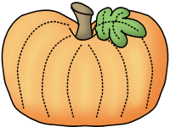

**Brian**



**Sonja Darden’s Kindergarten Class**

**Buck Lake Elementary** 488-6133 [dardens@leonschools.net](mailto:dardens@leonschools.net)

**October 10, 2022**

