**Savvas Reading-** **Unit 2 Week 4**

***Unit Question:***

What do living things need?

***Focus:*** How do different animals eat their food?

***Text: Open Wide!***

***Letter Recognition & Sounds:***

Gg and blends

***Sight Words:*** four, five, here, it, if

***Vocabulary:***

shark, eagle, turtle, humming bird

***Genre:*** Informational Text

* Print Awareness
* Make and Confirm Predictions

***Language and Conventions:***

Verbs

**Math- *Chapter 5: Addition***

***The Chapter 5 test is scheduled for Thursday, November 17th.*** I do not need the homework packet returned.

**Social Studies-** Veterans Day

**Science-** Animal Characteristics

I want to send out a big welcome to our newest Buck Lake bobcat, Ma’riah! We are so glad she is here!



**November**

**Birthdays**

21st Haylee

23rd Koen

**Thursday, November 10th**

There will be a substitute in class Thursday. I will be on campus but have a mandatory district training. If your child has a change in transportation for going home, please call the office directly 488-6133. Thanks!

**Friday, November 11th**

Veterans Day (No School)

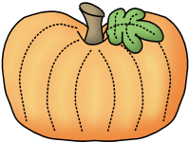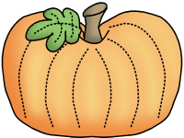

**Maryum**



**Sonja Darden’s Kindergarten Class**

**Buck Lake Elementary** 488-6133 [dardens@leonschools.net](mailto:dardens@leonschools.net)

**November 7, 2022**

