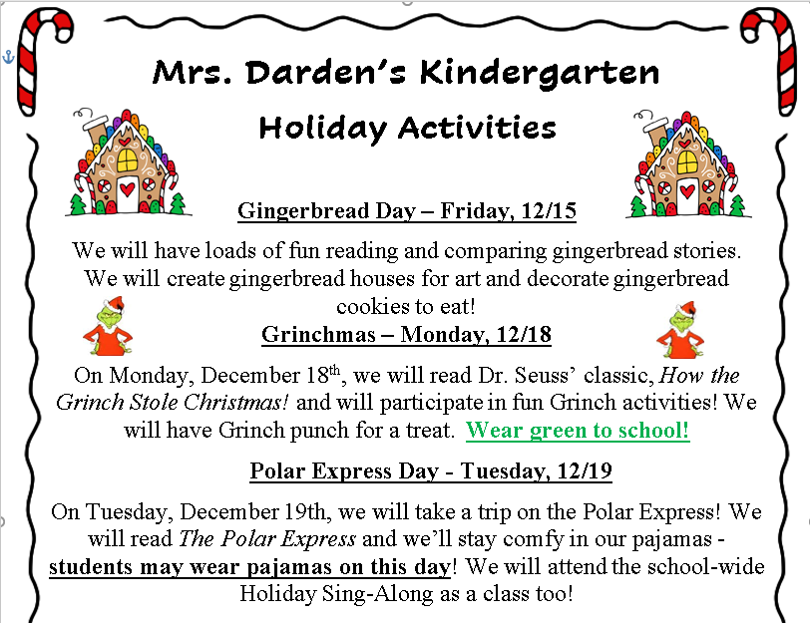

BLE Holiday Connection Information

[Click here to sign up if interested.](https://www.signupgenius.com/go/10C094CABAB2CAAFB6-46226404-bobcat#/)

Thank you!



**Tuesday, 12/5**

PTO Board Meeting

**Friday, 12/8**

Share Night AR Workshop

**Friday, 12/15**

Gingerbread Day

**Monday, 12/18**

Grinchmas-wear green

**Tuesday, 12/19**

Polar Express Day-wear pajamas

School-wide Holiday Sing-Along



The PTO is planning ahead for the BLE carnival. If you are willing to send in something for our class Lego Tisket Tasket basket the link can be found below. Thanks!

[**Lego Basket Sign-Up Genius**](https://www.signupgenius.com/go/10C0E4BAEAD2DA4FBC07-45107084-lego#/)

**Savvas Reading-** **Unit 2 Week 3**

***Unit Question:***

What do living things need?

***Focus:*** How do we know what we need?

***Text: Do We Need This?***

***Letter Recognition & Sounds:***

Hh and Ll

***Sight Words:*** one, two, three

***Vocabulary:*** water, food, shelter

***Genre:*** Fiction

* Main idea/details
* Characters

***Language and Conventions:***

Verbs

**Math- Chapter 6: Order and Compare Numbers Through 10**

The Chapter 6 test will be 11/28.

**Science-** Living Things

**Social Studies-** Holiday Traditions

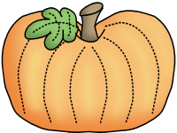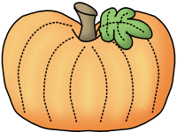

**Caplin**



**Sonja Darden’s Kindergarten Class**

**Buck Lake Elementary** 488-6133 [dardens@leonschools.net](mailto:dardens@leonschools.net)

**November 27, 2023**

