**Savvas Reading-** **Unit 2 Week 5**

***Unit Question:***

What do living things need?

***Focus:*** Exercise is Fun

***Text: Run, Jump, and Swim***

***Letter Recognition & Sounds:***

Ee, Ww, Yy

***Sight Words:***

from, go, yellow, orange

***Vocabulary:***

swim, push, climb, carry

***Genre:*** Persuasive Text

* Text Structure

***Language and Conventions:***

Prepositions

**Math- *Chapter 5: Addition***

***The Chapter 5 test is scheduled for Thursday, November 17th.***

**Social Studies-** *Let’s Find Out: My Weekly Readers*- Traditions and Happy Thanksgiving



**Maryum**



The PTO is planning ahead for the BLE carnival. If you are willing to send in something for our class Lego Tisket Tasket basket the link can be found below. Thanks!

<https://www.signupgenius.com/go/10c0e4baead2da4fbc07-lego>

**Wednesday, 11/16**

Progress Alerts Posted

**11/21-11/25**

Thanksgiving Break

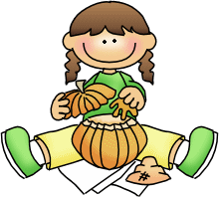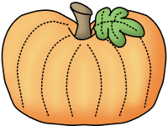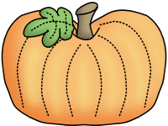

**Sonja Darden’s Kindergarten Class**

**Buck Lake Elementary** 488-6133 [dardens@leonschools.net](mailto:dardens@leonschools.net)

**November 14, 2022**

