**Savvas Reading-** **Unit 3 Week 1**

***Unit Question:***

Why do we like stories?

***Focus:*** What can we learn from stories?

***Text: How Anansi Got His Stories***

***Letter Recognition & Sounds:***

Jj and Xx

***Sight Words:***

said, was, where, on, or

*Unit 3 sight word list is in folders today!

***Vocabulary:*** king, lion, leopard

***Genre:*** Fiction

* Folktales

***Language and Conventions:***

pronouns

**Math- *Chapter 9: 3-D Shapes***

***The Chapter 9 test is scheduled for Friday, December 9th.***

**Social Studies-** Holiday Traditions and Holidays Around the World



**Journee’**



**3rd** Rex

**7th** Annabelle

**11th** Piney

**24th** Wyatt

**26th** Kevin

**31st** Ma’riah

**Monday, 12/5**

Kindergarten FAST Testing begins today!

**Thursday, 12/8**

Students watch school play ***Elf Impersonator*** at 9:45.

**Wednesday, 12/14**

Decorate Gingerbread Cookies

**Thursday, 12/15**

Grinch Day (Wear green!)

**Friday, 12/16**

* School-Wide Holiday Sing-Along (Wear PJ’s!)
* End of 2nd 9 weeks

**12/19-1/2** Winter Break

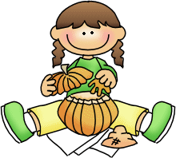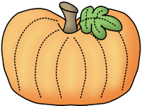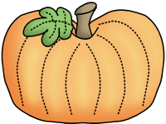

**Sonja Darden’s Kindergarten Class**

**Buck Lake Elementary** 488-6133 [dardens@leonschools.net](mailto:dardens@leonschools.net)

**December 5, 2022**

