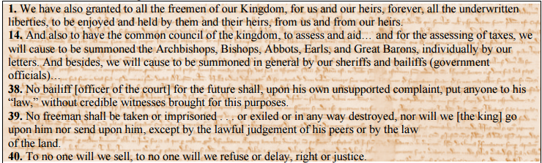

1. The right of Due Process originally came from the Magna Carta. It means that a person cannot be arrested or imprisoned without going through a fair legal process. Identify and quote the line in the document that refers to this right.
2. What groups are included in the common council in article 14? What group of people are left out?
3. The Common Council later became the English Parliament. According to “The Development of Parliament” on p 247, how did the Parliament later become fairer for all people in England?