**Name: _____________________________ Date: ___________ Per.: ______**

**The Fractional Reserve Banking and the Money Multiplier**

1. Thomas takes $1000 from under his mattress and deposits it into a newly opened checking account at Good Fortune Bank. The bank is required to keep 10% of the deposit as reserve requirement, but the remaining dollars are excess reserves and can be either kept by the bank as reserves or lend out in form of a loan.

A) Complete the balance sheet of Good Fortune Bank.

B) Use the equation of the money multiplier and determine the maximum amount of money that could be created with the $1000 deposit.

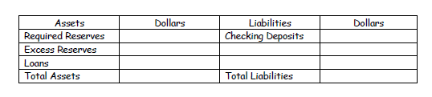

2. Assume that the total amount excess reserves you calculated will be lend out to Mike, who would like to purchase a new computer. Further assume that the computer store banks with Good Fortune Bank and therefore deposits the purchasing price of $ 850 in its bank account.

A) Complete the balance sheet of Good Fortune Bank.

B) By how much do the liabilities increase?

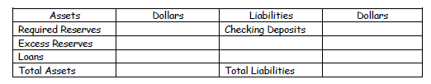

C) What is the maximum loan the bank could hand out based on its excess reserves?

D) If Mike keeps the difference between the loan and the purchasing price of its new computer at home under his mattress, will this increase or decrease the money supply? Explain your answer.

The Federal Reserve decreased the reserve requirement for its member banks from 10% to 5%. Complete the following assignments (New Case Scenario) and identify

A) How the reserve requirement affects the money multiplier, and

B) The effect of changes in the money multiplier on the total amount of money that can be created based on the $1000 deposit.

**New Case Scenario – Don’t continue with previous information!!!**

3. Thomas takes $1000 from under his mattress and deposits it into a newly opened checking account at Good Fortune Bank. The bank is required to keep 5% of the deposit as reserve requirement, but the remaining dollars are excess reserves and can be either kept by the bank as reserves or lend out in form of a loan.

A) Complete the balance sheet of Good Fortune Bank.

B) Use the equation of the money multiplier and determine the maximum amount of money that could be created with the $1000 deposit.



4. Assume that the total amount of excess reserves you calculated will be lent out to Mike, who would like to purchase a new computer. Further assume that the computer store banks with Good Fortune Bank and therefore deposits the purchasing price of $ 900 in its bank account.

A) Complete the balance sheet of Good Fortune Bank.

B) By how much do the liabilities increase?



C) What is the maximum loan the bank could hand out based on its excess reserves?

5. Would the balance sheet of the bank change if instead of Thomas depositing $ 1000, the Fed would have bought a bond of $ 1000 from Good Fortune Bank and hence increased the bank’s money supply by $ 1000?