**Changes in Aggregate Demand Outside Work Activity**

***This assignment is due on October 11th.***

After watching Jason Welker’s “An Introduction to Aggregate Demand” video found at <https://www.youtube.com/watch?v=adgqvtlUtMk>, answer the following questions.

1. What factors cause a change in AD?

2. What does household wealth refer to?

3. What determines the level of government spending?

4. How do exchange rates impact AD?

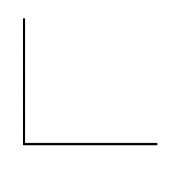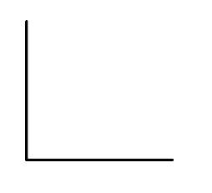Determine the effect on aggregate demand of each of the following events. Explain whether it represents a change in quantity demanded represented by a movement along the curve (up or down) or a change in demand represented by a shift of the curve (left or right). (Remember, explain means how and why.) Then, in a correctly labeled graph, show how each of the following will affect the AD curve. ***Be sure to number the graphs for ease of grading.***

1. Business owners are less optimistic about the health of the economy.

2. The government decreases welfare and veteran’s benefits.

3. The Federal Reserve increases interest rates.



4. A rising price level decreases the value of money held for purchases.



5. The government lowers personal income taxes.



6. Consumers expect the job market to be much stronger in the next few months.



7. The stock market has reached new records high levels of value.

8. The stock of physical capital has been falling for nearly a year.

Checking for Understanding – Answer the following questions below.

1. The interest rate effect is the tendency for changes in the price level to affect

A. the quantity of investment demanded and thus affect interest rates.

B. export demand and thus affect aggregate demand.

C. interest rates and thus affect the quantity of investment and consumption demanded.

D. real incomes and lead to shifts in potential output.

E. interest rates and thus affect the productivity of existing capital equipment.

2. Draw a correctly labeled graph to show the impact of an increase in taxes on aggregate demand.

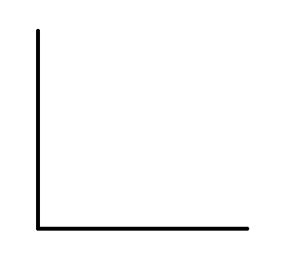

3. When the aggregate price level rises, this will, other things equal,

A. lead to a rightward shift in the AD curve.

B. lead to a leftward shift in the AD curve.

C. result in a decrease in the quantity of aggregate output demanded.

D. result in an increase in the quantity of aggregate output demanded.

E. result in a decrease in the quantity of aggregate output supplied.