For Immediate Release 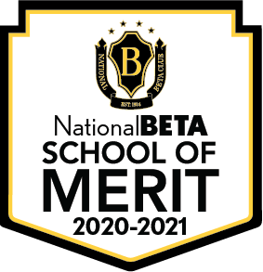

4/29/21

**Montford Middle School Named National Beta School of Merit**

*Tallahassee, FL, 4/29/21-Leon County Schools*-is proud to announce that Montford Middle School is a *2020-2021 National Beta School of Merit*. The school earned this recognition by offering National Beta to all eligible grades on their campus.

The *National Beta School of Merit* award is given to honor a club’s dedication and commitment to academic excellence. To achieve this prestigious honor, a school must include members from all eligible grade levels in their Beta club. This year, only 29% of Beta Clubs across the country received this award.

In a congratulatory letter to the school, Bobby Hart, CEO said “Thank you for your continued support of National Beta and commitment to developing future leaders!”

“I’m beyond proud of the accomplishments of our Beta students. They aim high, and work diligently to reach all of their goals. Even during this most crazy of years, our club was able to collect and delivery an enormous number of toiletries to a local homeless shelter, The Kearney Center.”-Mrs. Lowery

**About National Beta**    
With more than 500,000 active members and 9,000 chapters nationally and internationally, National Beta has become the nation’s largest independent, non-profit, educational youth organization. National Beta recognizes outstanding achievement, promotes character and social responsibility, encourages service involvement to school and community, and fosters leadership skills. National Junior Beta includes grades 4-8 and National Senior Beta includes grades 9-12. The National Beta program offers over $300,000 annually to its Senior Beta Members. Visit betaclub.org for more information.