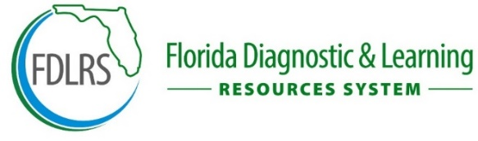
2025-26 AUTISM SPECTRUM DISORDER ENDORSEMENT COURSES SCHEDULE
The following three (3) modules are offered by FDLRS Miccosukee AT NO COST to satisfy the course requirements for ASD Endorsement (240 hours), for educators in Gadsden County, Jefferson County, Leon County, Taylor County, Wakulla County, FSU Lab School, FAMU Lab School and Tallahassee Collegiate Academy.

MODULE | DESCRIPTION | 2025-26
Nature and Needs Assessment and Diagnosis of Students with Autism | This course enables educators to build expertise in autism spectrum disorders through evidence-based practices, assessments, and IEP development. Explore sensory needs, communication styles, and individualized supports. Includes field experience and 80 in-service credits—ideal for educators dedicated to inclusive teaching. | 8/25/25 to 11/21/25  Registration to open by 5/5/25 and closes on 8/20/25
Applied Behavioral Analysis and Positive Behavior Supports for Students with Autism | This course enables educators to gain practical, evidence-based strategies to promote positive behavior and reduce challenges. This hands-on module covers ABA, behavior assessments, reinforcement, social skills, and self-monitoring. Includes 80 in-service credits with embedded field experience—perfect for educators in inclusive or specialized settings. | 11/17/25 TO 2/13/26  Registration to open by 10/6/25
Augmentative/Alternative Communication Systems and Assistive/Instructional Technology for Students with Autism Spectrum Disorder with Field  Experience | This course enables educators to develop and demonstrate knowledge and skills in augmentative/alternative communication systems (AAC), functional communication, assistive tech, and transition planning for students with autism. Includes hands-on field experience and 80 in-service credits—designed for educators supporting lifelong learning and independence. | 2/2/26 to 4/24/26  Registration to open by 1/5/26

Each online ASD endorsement course is 11-12 weeks long. Courses offer flexibility to work at your convenience and are completely online. The endorsement courses can be taken in any order. Modules will be advertised on FDLRS Website, http://www.fdlrsmicco.org under Professional Learning. Contact brennanl@leonschools.net with any questions. The Teacher Education Add-on Program for Certification in ASD Endorsement is designed to provide teachers with local access to professional learning. The target audience is for teachers who are supporting students with autism spectrum disorder; however, the modules are appropriate for certification renewal and /or professional learning. Credits earned through this program may not be used for college or university credit. It will be the responsibility of the participant to verify with their local staff development office and/or the Florida Department of Education certification office any additional certification requirements.

