

**Distance Learning**

**with**

**Week 3 (April 13th-17th) - DUE April 20th at 9:30 a.m.**

**Required Materials**

We’re going to be reading George Orwell’s *Animal Farm* starting this week. That means you’re going to need access to that book.

If you can get a paper copy of this book, cool!

Alternatively, you can read the whole book here: <http://gutenberg.net.au/ebooks01/0100011h.html>

And you can listen to the whole book here:

<https://www.leonschools.net/Page/46276>

**Changes/Additions this week**

1) I’m doing this week’s work **with you**! Based on your votes, I’ll be going live on Teams at 11:30 on Tuesday (4/14) and 1:30 on Thursday (4/16). We’ll do the first two tasks together on Tuesday (read Ch. 1 and Trace the Argument) and the second two on Thursday (read Ch. 2 and Guiding Questions). You can tune in (ONLY IF YOU WANT TO) and have class with me! I’ll read, student volunteers will read, we’ll discuss answers, and I even made an at-home Wheel of Reading. 😊 I will also post the videos of these meetings in Teams, so you can watch them later if you can’t make the meeting time.

2) You will notice that this week’s assignments are task-based, not day-based. Please feel free to work at your own pace. You might do all six tasks in a single sitting; you might prefer to wait and do them with our “class.” Either is perfectly fine with me.

**Week 3 Overview Checklist –**

* **Read Chapter 1 of *Animal Farm***
* **Trace the Argument**
* **Read Chapter 2 of *Animal Farm***
* **Guiding Questions**
* **Covid Crisis Journal #2**
* **Family Game Time - Disruptus**

**Parent Assignment for Week 3**

* **Check your child’s grades in Focus. That will continue to be the main communication tool for feedback on assignments. Email/Remind text Mrs. Day with any questions you have about your student’s grades!**
* **Task: Read Chapter 1 of *Animal Farm***
* **Task: Trace the Argument**

**\*Remember that I’ll be reading the chapter AND doing this task with my students on Tuesday at 11:30.**

**Just join the “meeting” in Teams to be part of our class!**

While it may not seem like one, Old Major’s speech in Chapter 1 is an argument. We’re going to “trace” it as we’ve done before with other pieces of argumentative writing. Reread his speech, and find the following elements. **Each (except your evaluation) will be a direct quotation from the text.**

Claim: ____________________________________________________________

Reason: ___________________________________________________________

Evidence (list two pieces): _______________________________________

___________________________________________________________________

Opposing Claim: ___________________________________________________

Counterargument: __________________________________________________

Your Evaluation: _________________________________________________

* **Task: Covid Crisis Journal #2**

Remember, you don’t **have** to answer my prompt. If you wish, you may simply write a paragraph (five-seven sentences) about what you’re thinking, doing, reading, feeling, or experiencing (etc.) during this moment in history.

**Prompt #2 – How do you feel about missing school? Do you miss your friends, or are you able to maintain those relationships virtually? Do you…dare I ask…miss your teachers? What, about the experience of going to school, *do* you miss?**

________________________________________________________________________________________________________________________________________________________________________________________________________________________________

________________________________________________________________________________________________________________________________________________________________________

________________________________________________________________________________________________________________________________________________________________________

* **Task: Read Chapter 2 of *Animal Farm***
* **Task: Guiding Questions**

**\*Remember that I’ll be reading the chapter AND doing this task with my students on Thursday at 1:30.**

**Just join the “meeting” in Teams to be part of our class!**

1. Fill in the chart below to study the **characterization** of Snowball.

|  |  |  |  |
| --- | --- | --- | --- |
| Adjectives the author uses to describe this character: | Significant actions taken by the character in this chapter: | Significant words spoken by this character in this chapter: | My predictions for this character: |
|  |  |  |  |

2. In what **point of view** is this story written?  ________________

3. What is the **mood** of Chapter 2? Find a quotation that communicates that mood. ___________________________________________

________________________________________________________________________________________________________________

4. What do you think happened to the milk at the end of Chapter 2? How might this **foreshadow** events to come? ___________________________

________________________________________________________

________________________________________________________

* **Task: Family Game Time – *Disruptus***

Disruptus is a game of creativity and connection. Below, you’ll find a picture of an everyday object. Look at this picture, grasp what the purpose of the object is, and come up with a completely different way to achieve that same purpose. You are not limited by the boundaries of what is technically, realistically possible.

For example, if I were given this picture, I would see that it’s a hammock. Its purpose is to allow people to lie down and relax or sleep outside. My idea: design mechanical spiders who weave a silken web for you anywhere you want, which perfectly conforms to your body, and which you can relax in and sleep outside.

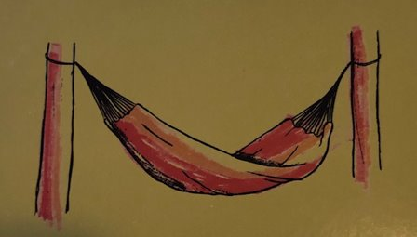

Get it? That’s the game. So, look at your picture below. Grasp what the purpose of the object is, and come up with a completely different way to achieve that purpose.

**When you have an idea, type it in YOUR CLASS’ “Teams” chat.**

**At the end of this week, our whole class will vote on our favorite idea. Mrs. Day will mail (yes, actual mail that comes to your house) prizes to each class winner!**

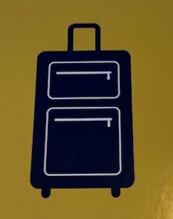

**NOTE ABOUT TURNING STUFF IN – FOR ALL OF MY WORK you can write your answers on a piece of notebook paper and email me a picture of it if that’s what’s easiest! OR, print the packet and write on it, then email that pic. OR copy & paste the doc and edit it and “share.” Or, complete it in Teams.**

**What works for you works for me. 😊**